

**Software Specification**

Donation Management Software



251684784 Hafsah Shahbaz

251683919 Kiran Qaiser

251606966 Syeda Manal Ammad

Forman Christian College (A Chartered University)

COMP 220-B: Software Engineering

[Saba](http://tmoodle.fccollege.edu.pk/moodle/user/view.php?id=10506&course=1) Toor

Assignment Due Date: 06/06/2023



**Donation Management Software**

Table of Contents

Introduction 3

Domain And Overview 3

Software Development Life Cycle Process 4

Software Architecture 5

Work Breakdown Structure 6

Activity on Node (AON) 6

User Requirements 10

System Requirements 11

Use Case Diagram 15

Fully Dressed Use Cases 16

Domain Models for Use Cases 41

Sequence Diagrams for Use Cases 45

Class Diagrams for Use Cases 51

User Interface 56

Test Cases 68

Future Work 77

Conclusion 77



**Donation Management Software**

# Introduction

In recent years, there has been a growing trend of people wanting to donate to various organizations and causes. The lack of openness and authenticity in the donation process, however, is one of the biggest problems faced by donors. People frequently find themselves giving money to fictitious groups or people who represent themselves as activists for a cause. We are creating a donation management mobile app to address this problem by giving donors and NGOs an effortless way to register, authenticate, and manage donations. A creative solution that makes use of technology to make it simple for people to donate to the organizations they want is the donation management mobile app. With the help of the app, users will have access to a safe and secure platform where they can donate any amount to the organization of their choice without having to question the legitimacy of the cause. Additionally, the app will make it possible for NGOs to register and manage donations efficiently and transparently.

# Domain And Overview

Domain:

Non-profit sector, Donation management, Mobile application development

Overview:

The donation management software aims to end the prevalent begging system in Pakistan by providing a secure and transparent platform for regulated donations. The software, in the form of a mobile application, enables individuals to direct their sadqa, zakat, and charity to verified NGOs that genuinely help people in need. By channeling donations through the app, users can be confident that their contributions will be utilized wisely and reach the intended recipients. This system not only combats the presence of fraudulent beggars but also empowers individuals to make a significant impact on the lives of those in need. Through comprehensive features such as user authentication, multiple payment gateways, NGO management tools, and personalized filters, the software provides an alternative for individuals in need to seek shelter, support, and assistance from legitimate NGOs. The ultimate goal is to foster a more compassionate and supportive society, where people can rely on verified NGOs for help instead of resorting to begging.

# Software Development Life Cycle Process

The Waterfall model can be well-suited for smaller scale projects with well-defined and straightforward requirements which is why we choose it for our project. It helped us maintain clarity and structure throughout the development process. The Waterfall model emphasizes gathering and documenting requirements at the beginning of our project. This helped ensure a clear understanding of our project scope and minimizes the risk of scope creep. This model follows a linear and structured approach, where each phase is completed before moving to the next. This made it easier to plan and schedule the project since the requirements, design, and implementation phases are clearly defined in it.Another advantage is that with the waterfall model, testing is typically conducted at the end of the development process. This sequential approach allows for a focused and comprehensive testing phase, as the entire system is available for testing, ensuring better quality control.

# Software Architecture

For our Donation Management System, we used layered software architecture .It is a a three-tier architecture. The three tiers consist of the presentation layer, application layer, and data layer.

Presentation Layer:

* the user interface (UI) and user interaction.
* It handles the presentation and rendering of web pages, forms, and visual elements.

Application Layer:

* This layer contains the business logic and acts as an intermediary between the presentation layer and the data layer.
* It handles user requests, processes input, performs validations, and orchestrates system functionalities.

Data Layer:

* This layer is responsible for storing and managing data used by the system.
* It encompasses the database management system (DBMS) and related data storage components.
* Commonly used DBMS options include MySQL, PostgreSQL, MongoDB, or SQLite.
* The data layer manages the storage and retrieval of donor information, donation records, campaign details, and other relevant data.

We choose this architecture because each layer has its own responsibilities, promoting modularity and maintainability. Layers can be scaled independently, allowing for better performance optimization and resource management. Changes in one layer do not impact the others, facilitating modifications and upgrades. Components within each layer can be reused in other parts of the system or future projects. The layered approach helps in implementing security measures at each level, protecting sensitive data.

# Work Breakdown Structure

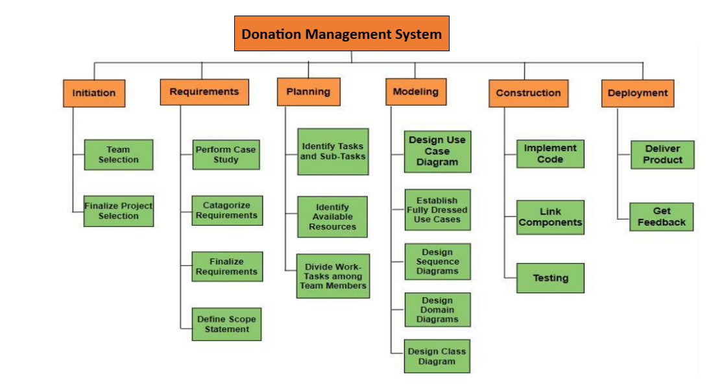

# Activity on Node (AON)

* AON Table:

| **Activities** | **Durations (Days)** | **Predecessor** |
| --- | --- | --- |
| Start | 0 | Null |
| Team Selection | 7 | Start |
| Finalize Project Selection | 3 | Team Selection |
| Perform Case Study | 12 | Finalize Project Selection |
| Categorize Requirements | 5 | Perform Case Study |
| Finalize Requirements | 5 | Categorize Requirements |
| Define Scope Requirements | 2 | Finalize Requirements |
| Identify Tasks and Sub-Tasks | 7 | Define Scope Requirements |
| Identify Available Resources | 4 | Define Scope Requirements |
| Divide Work Tasks among Team Members | 3 | Identify Available Resources |
| Design Use Case Diagram | 3 | Divide Work Tasks among Team Members |
| Establish Fully dressed Use Cases | 5 | Design Use Case Diagram |
| Design Sequence Diagrams | 9 | Establish Fully dressed Use Cases |
| Automating Workshop Software | 2 | Establish Fully dressed Use Cases |
| Design Domain Diagrams | 1 | Design Domain Diagrams |
| Design Class Diagrams | 0 | Design Domain Diagrams |
| Implement Code | 8 | Design Sequence Diagrams |
| Link Components | 5 | Implement Code |
| Testing | 3 | Link Components |
| Deliver Product | 5 | Testing |

* 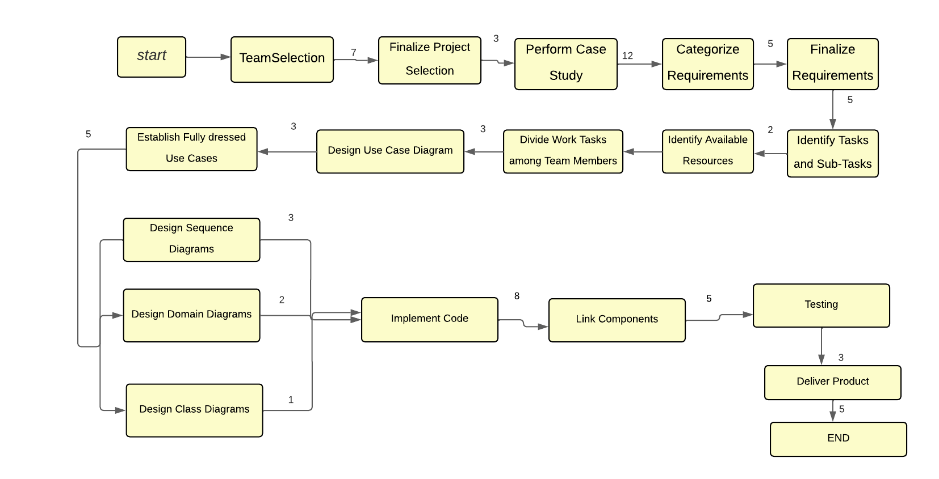AON Diagram:

# User Requirements

1. Ngo’s and donors will be able to register to create their account to login.
2. Donors should select the donation type and specify the amount.
   * Multiple secure payment gateway options should be available like Easy Paisa, Jazz Cash, Sada Pay etc.
   * Donors should receive confirmation and receipts of their donations.
3. NGOs should provide program descriptions, goals, and impact achieved.
   * Donors should have access to information about specific projects or causes supported.
4. Users should be able to book visits to NGOs to witness their work.
5. Users should be able to apply filters and search for NGOs based on location, cause, or type of work.
6. Individuals seeking assistance should submit requests for essential services.
   * The system should match requests with suitable NGOs for assistance.

# System Requirements

Functional Requirements:

1. User Registration/ Management:
   * The system should allow users to create an account by providing their personal information, including name, email address, and contact number.
   * Registration options should include donors and NGO representatives.
   * User profile management (editing contact details and assistance preferences)
2. User Authentication:
   * Users should log in with a unique username/email and password.
   * Additional authentication methods like two-factor authentication may be implemented.
3. Donation Process:
   * Donors should be able to select the type of donation (e.g., sadqa, zakat, charity) and specify the donation amount.
   * Users will be able to filter the NGOs based on their location, Programs they are running and most popular NGOs.
   * Multiple secure payment gateway options should be available to facilitate safe and convenient transactions.
   * Donors should receive confirmation and receipts for their donations.
4. NGO Registration and Management:
   * NGOs should register with their organization details.
   * NGOs will have the option to select from multiple membership plans either paid or free to boost their donation amounts received.
   * Additional authentication methods like two-factor authentication, and verification of NGO documents may be implemented.
   * NGOs should be able to manage their profiles and update information and options to change their membership plans.
5. Donation Tracking:
   * Donor view and tracking of donation history.
   * The system should provide donors with information about the utilization of their donations by NGOs.
   * Status tracking for individuals seeking assistance.
6. Payment Gateway Integration:
   * Integration of multiple secure payment gateways
   * Support for various payment methods
   * Donors should have the flexibility to choose their preferred payment method, such as credit/debit cards, online banking, or mobile wallets.
   * Verification of payments
7. Communication and Notifications:
   * The system should send notifications to donors to acknowledge their donations and provide updates on the impact achieved through their contributions.
   * Donors should have the option to receive regular updates and newsletters from the NGOs they support.
8. Assistance Request Handling:
   * Submission of assistance requests by individuals
   * Dashboard for NGOs to review and respond to requests.
9. Mobile App Compatibility:
   * Development of a mobile application
10. Reporting and Analytics:
    * Generation of reports and analytics on donation trends and impact
    * Comprehensive analytics for administrators and NGOs
11. Maintenance and Support:
    * Regular maintenance, bug fixes, and updates
    * Technical support for users

Non-functional Requirements:

1. Usability: Intuitive and user-friendly interface
2. Performance: Efficient response time, Quick OTP generation, and seamless navigation
3. Security: Protection of user data and secure transactions
4. Reliability: Minimal downtime and uninterrupted access
5. Compatibility: Support for popular mobile operating systems
6. Scalability: Ability to handle many users and transactions
7. Reporting: Comprehensive reporting capabilities
8. Maintenance: Regular maintenance and support
9. Integration: Seamless integration with multiple payment gateways
10. Data Privacy: Compliance with data protection regulations.
11. Storage Space: The software should utilize an adequate amount of storage space based on the number of users.
12. Quick Appointment Booking: The system should allow users to book appointments quickly and efficiently.

# Use Case Diagram

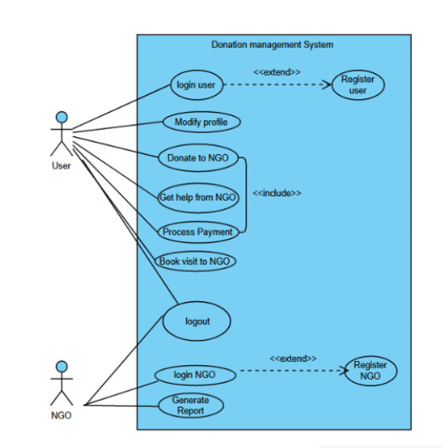

Use-cases:

1. Register User
2. Login User
3. Register NGO
4. Login NGO
5. Modify Profile
6. Donate To NGO
7. Process Payment
8. Book Visit To NGO
9. Get Help From NGO
10. Generate Reports
11. Logout

# Fully Dressed Use Cases

1. **Register User**

|  |  |
| --- | --- |
| Use case name: | Register User |
| Use case ID: | UC-010 |
| Super use case: | N/A |
| Actor(s) | User |
| Brief description | The process of adding new donors to the website is addressed by the donor registration use case. Users can register for an account, which allows them to log in later and explore the mobile application. |
| Preconditions | The donor registration system is available and prepared. |
| Post-conditions | The system has successfully recorded the donor's data. |
| Flow of events | 1. User accesses the registration page. 2. Enter Email/Phone Number and password. 3. The system checks the email address and other information you submitted to make sure it's formatted correctly. 4. Verification OTP sent to either the email address or the phone number. 5. The system notifies the user that their registration is complete and certifies that it was successful by displaying a message. 6. Extend (User login) |
| Alternative flows and exceptions | If user is already registered, they can simply log in. |
| Priority | High |
| Non-functional requirements | * User-friendly instructions, validation checks, and user-friendly donor registration procedures should all be included. * The system must uphold the confidentiality and privacy of donor data while adhering to all relevant data protection laws. |
| Assumptions | We assume that the user is not pre-registered. |
| Issues | * Incorrect email address provided, or user is already signed up with the same email address. * User doesn’t receive OTP. * Password requirements are not satisfied. |
| Source | N/A |

1. **Login User**

|  |  |
| --- | --- |
| Use case name: | Login user |
| Use case ID: | UC-002 |
| Super use case: | N/A |
| Actor(s) | User |
| Brief description | In the "Login User" use case, a registered user accesses their account. On the login screen, the user enters both a password and a username. When credentials are submitted, the system checks to see whether they are accurate and if so, allows access to the user's account. |
| Preconditions | The user has active login credentials and has registered on the app. |
| Post-conditions | After successfully logging in, the user is given access to their account. |
| Flow of events | 1. Enter Email/Phone number and password. 2. Two Factor Verification through email or phone number. 3. The system verifies that the user has successfully logged in and takes them to their account dashboard or the specified landing page. 4. Login |
| Alternative flows and exceptions | If user is already logged in, no need to execute this |
| Priority | High |
| Non-functional requirements | The system should have enough storage to maintain to accept new users. |
| Assumptions | We assume that the user is not already logged in. |
| Issues | User doesn’t receive OTP |
| Source | N/A |

1. **Register NGO**

|  |  |
| --- | --- |
| Use case name: | Register NGO |
| Use case ID: | UC-003 |
| Super use case: | N/A |
| Actor(s) | NGO |
| Brief description | An NGO representative starts the registration process to create an account on the donation management system. To authenticate their identification and register their NGO in the system, they give the essential information and documentation. The representative of the NGO has a choice between a paid and a free membership option, each with unique features and advantages. |
| Preconditions | The representative for the NGO seeks to register their organization and has access to the donation management system. |
| Post-conditions | The NGO is identified and acknowledged in the contribution management system upon successful registration with the selected membership plan applied. |
| Flow of events | 1. The NGO representative opens the app in and selects NGO registration and opens the registration form. 2. NGO representatives enter the details – Email Address, password, contact information and upload supporting documents. 3. The representative selects the desired membership plan: paid or free. 4. System verifies the provided information and documents. 5. If the paid membership plan is selected, they make the required payment and give further information for billing. 6. The system then accepts the registration of the NGO when the verification procedure is finished. 7. NGO receives email about their registration whether accepted or declined. 8. Extend (NGO login) |
| Alternative flows and exceptions | The representative can get help from the system support staff in the event of registration being declined or technical problems. |
| Priority | High |
| Non-functional requirements | The system must have enough storage to safely preserve NGO registration data and related documentation. |
| Assumptions | The NGO representative is prepared for the registration procedure with the required data and paperwork. |
| Issues | * Documents failed to upload. * NGO membership payment fails if insufficient balance in account or other technical issues. |
| Source | N/A |

1. **Login NGO**

|  |  |
| --- | --- |
| Use case name: | Login NGO |
| Use case ID: | UC-004 |
| Super use case: | N/A |
| Actor(s) | NGO |
| Brief description | A registered NGO accesses their account on the app. On the login screen, the NGO enters both a password and a username. When credentials are submitted, the system checks to see whether they are accurate and if so, allows access to their account. |
| Preconditions | The NGO must be already registered on the website. |
| Post-conditions | The NGO logs in and gains access of its account. |
| Flow of events | 1. NGO enters email/Phone Number and password. 2. Two Factor Verification through email or phone number. 3. The system verifies that the user has successfully logged in and directs them to their account dashboard or the specified landing page. |
| Alternative flows and exceptions | If incorrect login credentials are entered system will deny access to the account and the NGO will have to try again. |
| Priority | High |
| Non-functional requirements | * The system should be capable of storing many login credentials. * The system should have enough speed to match the data with the long list of multiple different login credentials. |
| Assumptions | We assume user is not already logged in. |
| Issues | * Slow internet speed * OTP not generated |
| Source | N/A |

1. **Modify Profile**

|  |  |
| --- | --- |
| Use case name: | Modify Profile |
| Use case ID: | UC-005 |
| Super use case: | Login User, Login NGO |
| Actor(s) | NGO/User |
| Brief description | User can modify their account details. |
| Preconditions | User must have logged in. |
| Post-conditions | User successfully changes account information. |
| Flow of events | 1. User clicks on profile icon. 2. User chooses ‘Edit Profile’ from the web page. 3. User chooses the relevant field, in case of being a non-NGO user u can choose among Name, Number, Payment details and email. 4. In case of being the NGO, choose between Name, Number, Staff details, Head details, Classification, email and membership plans. 5. Edit the previous information. 6. Authentication of new contact number and email is done by sending an OTP code to it. 7. Save |
| Alternative flows and exceptions | 1. Incorrect email or contact number will result in generation of an error message. 2. If the name or staff/head information takes more characters that the system accepts it generate an error message and it will not be saved. |
| Priority | Low |
| Non-functional requirements | * The system should have a high response speed to generate and authenticate codes. * It should immediately update new information. |
| Assumptions |  |
| Issues | * Slow internet speed * OTP not generated |
| Source | N/A |

1. **Donate To NGO**

|  |  |
| --- | --- |
| Use case name: | Donate to NGO |
| Use case ID: | UC-006 |
| Super use case: | Login User |
| Actor(s) | User |
| Brief description | Donor can donate money to NGO |
| Preconditions | User must have added valid payment details. |
| Post-conditions | Donor successfully donates money. |
| Flow of events | 1. Include (User login) 2. User selects ’Donate Now’ button on the page of the NGO. 3. User enters amount that is wished to be donated in the donation form . 4. Users select type of donation (e.g.: Sadqa, Zakat, Charity etc.) 5. User selects a payment method. 6. Extend (Process Payment) |
| Alternative flows and exceptions | Not enough money in the user’s account. |
| Priority | High |
| Non-functional requirements | * The system should have a secure money transfer procedure. |
| Assumptions | Payment details already added. |
| Issues | OTP is not generated |
| Source | User Interview |

1. **Process Payment**

|  |  |
| --- | --- |
| Use case name: | Process Payment |
| Use case ID: | UC-007 |
| Super use case: | Donate to NGO |
| Actor(s) | User |
| Brief description | Secure transfer of funds and donations using different payment methods |
| Preconditions | The customer must provide valid payment information. |
| Post-conditions | Confirmation of a successful transaction, including the transaction ID and payment receipt. |
| Flow of events | 1. Include (Donate to NGO) 2. The payment amount must match the total cost of the transaction and payment data. 3. An OTP code is sent to the registered number. 4. User enters the OTP, and it is verified. 5. Receipt is generated with date,Id and amount. |
| Alternative flows and exceptions | OTP code is not verified. |
| Priority | High |
| Non-functional requirements | * The system should be capable of processing many incoming donations without experiencing performance issues. * User-friendly donation tracking should provide simple instructions and validation checks to ensure proper data entry. * In accordance with current data protection laws, the system shall ensure the confidentiality and security of donor and contribution information. |
| Assumptions | * the software has utilized encryption and other security procedures. |
| Issues | It can take a long time and requires careful attention to detail to integrate with a secure payment gateway. |
| Source | Data retrieved from a database or information submitted by the client. |

1. **Book visit to NGO**

|  |  |
| --- | --- |
| Use case name: | Book visit to NGO |
| Use case ID: | UC-070 |
| Super use case: | N/A |
| Actor(s) | User, System |
| Brief description | This use case involves the process of users booking visits to NGOs through the Donation Management Software. |
| Preconditions | * The user has registered and logged into the system. * The user has access to the list of NGOs and their available programs. |
| Post-conditions | The user successfully books a visit to the chosen NGO program and receives confirmation with the necessary details. |
| Flow of events | 1. Include (User login) 2. The user selects the option to browse NGOs and their programs. 3. The system displays a list of NGOs and their available programs, including details about the activities, locations, and dates. 4. The user can apply filters like- near me, to able to display a list of organizations that are in the same locality as the user has entered. 5. The user selects a specific program of interest and views more information about it. 6. The user decides to book a visit to the NGO by selecting the desired program and clicking on the "Book Visit" button. 7. The system prompts the user to provide additional information, such as the preferred date and the number of participants. 8. The user fills in the required information and submits the booking request. 9. The system verifies the availability of the requested date and updates the booking status. 10. If the requested date is available, the system confirms the booking and provides the user with a booking reference number. 11. The user receives a confirmation message containing the booking details, including the date, time, location, and any additional instructions. 12. The user can now plan and prepare for the visit to the NGO based on the provided information. |
| Alternative flows and exceptions | If the requested date is not available, the system notifies the user and suggests alternative dates or programs that may be suitable. |
| Priority | Medium |
| Non-functional requirements | Efficient and intuitive user interface, fast response time, robust security measures, and high system reliability are essential for a seamless and trustworthy booking experience. |
| Assumptions | * Stable internet connection. * Accurate program information from NGOs. * Users have basic software interface knowledge. |
| Issues | Poor usability, slow response time |
| Source | User Interview |

1. **Get Help From NGO**

|  |  |
| --- | --- |
| Use case name: | Get Help From NGO |
| Use case ID: | UC-080 |
| Super use case: | N/A |
| Actor(s) | User |
| Brief description | This use case describes the steps involved when a user seeks help or support from an NGO through the Donation Management Software. It allows users to explore various types of assistance provided by NGOs and establish communication for their specific needs. |
| Preconditions | * The user has registered and logged into the system. |
| Post-conditions | * The user receives the requested help or support from the selected NGO. * The user and the NGO maintain communication for ongoing assistance, if required. |
| Flow of events | 1. Include (User Login) 2. The user selects the option to seek help from the available menu. 3. The system presents a list of NGOs that offer various types of assistance. 4. The user reviews the list of NGOs and the types of help they provide. 5. The user selects an NGO from the list based on their specific needs. 6. The system displays detailed information about the selected NGO, including the types of assistance they offer, contact information, and any specific requirements or guidelines. 7. The user decides to proceed with the selected NGO for seeking help. 8. The user contacts the NGO through the provided contact information, which could be a phone number, email address, or an in-app messaging system. 9. The user communicates their specific needs or requests for assistance to the NGO. 10. The NGO responds to the user's request and provides guidance, support, or any necessary information. 11. The user follows the instructions and receives the help or support needed from the NGO. |
| Alternative flows and exceptions | * If the user cannot find a suitable NGO in the list, users can modify search criteria or contact support for assistance. * In case of communication issues or unsatisfactory assistance, users can report problems to support or seek help from another NGO. |
| Priority | High |
| Non-functional requirements | Ensure user-friendly interface, efficient performance, robust security, and high reliability for users seeking assistance from NGOs. |
| Assumptions | * Stable internet connection. * Accurate and up-to-date information from NGOs regarding assistance types * Users have basic software interface knowledge. |
| Issues | * Difficulty finding suitable NGOs * Communication issues or delays * Challenges in contacting NGOs or receiving timely assistance. |
| Source | User Interview |

1. **Generate Reports**

|  |  |
| --- | --- |
| Use case name: | Generate Reports |
| Use case ID: | UC-090 |
| Super use case: | N/A |
| Actor(s) | NGO |
| Brief description | This use case describes the process of generating reports on donations, activities, or impact by NGOs for internal or external purposes. |
| Preconditions | * The NGO must be registered and authenticated in the system. * Relevant donation, activity, and impact data must be available in the system. |
| Post-conditions | * Reports are generated based on the selected parameters and criteria. * Reports are available for viewing, printing, or exporting. |
| Flow of events | 1. Include (NGO login) 2. NGO staff or administrator selects the "Generate Reports" option in the system. 3. The system presents a menu of report types and parameters, such as donation reports, activity reports, or impact reports. 4. The NGO staff or administrator selects the desired report type and specifies the necessary criteria, such as date range, program, or donor category. 5. The system retrieves the relevant data from the database and generates the report based on the selected parameters. 6. The generated report is presented to the NGO staff or administrator for review. 7. The NGO staff or administrator can view, print, or export the report as needed. |
| Alternative flows and exceptions | * If there is no relevant data available for the selected parameters, the system displays an appropriate message. * If there are errors or issues in generating the report, the system displays an error message and allows the user to retry or contact support. |
| Priority | Medium |
| Non-functional requirements | * The system should generate reports in a timely manner to ensure efficient decision-making. * Reports should be formatted in a clear and organized manner for easy understanding. |
| Assumptions | * The system should generate reports in a timely manner to ensure efficient decision-making. * Reports should be formatted in a clear and organized manner for easy understanding. |
| Issues | There may be potential performance issues if the volume of data is large, requiring optimization techniques. |
| Source | Stakeholder requirements and project documentation. |

1. **Logout**

|  |  |
| --- | --- |
| Use case name: | Logout |
| Use case ID: | UC-0100 |
| Super use case: | Login User/NGO |
| Actor(s) | User/NGO |
| Brief description | A registered User can log out of its account. |
| Preconditions | The NGO/User must be already logged in on the website. |
| Post-conditions | The User/NGO logs out of their account. |
| Flow of events | 1. User selects the profile icon. 2. It selects the ‘Logout’ option from the web page. |
| Alternative flows and exceptions | N/A |
| Priority | Low |
| Non-functional requirements | * The system should have enough speed to successfully log out the user. |
| Assumptions | We assume user is not already logged out. |
| Issues | Slow internet speed |
| Source | N/A |

# Domain Models for Use Cases

1. Register User:

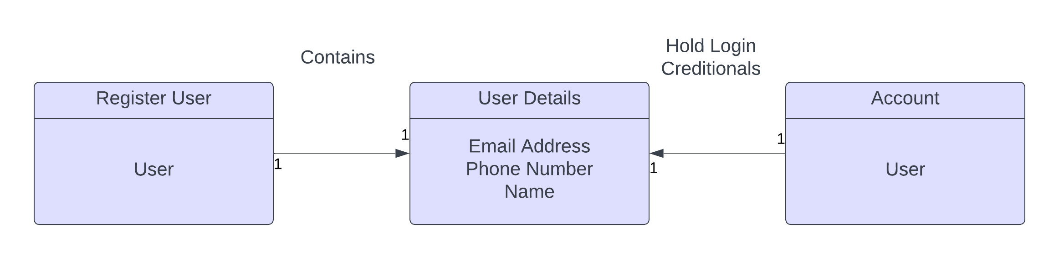

1. Login User:

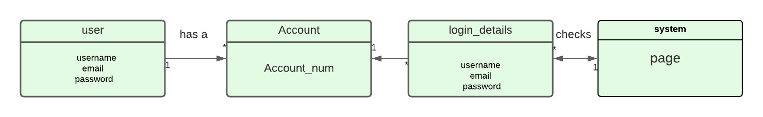

1. Register NGO:

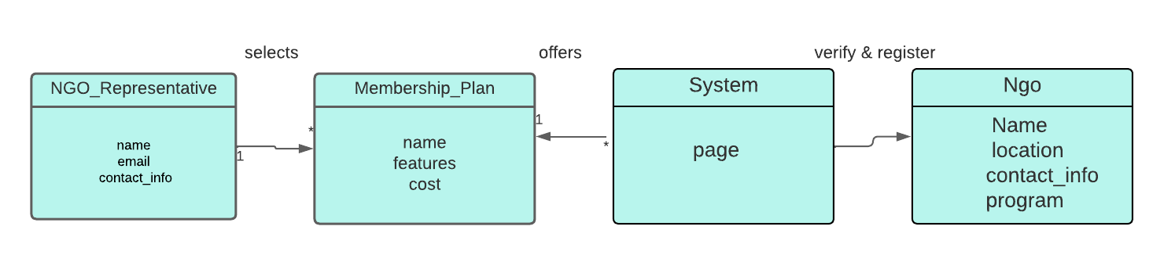

1. Login NGO:

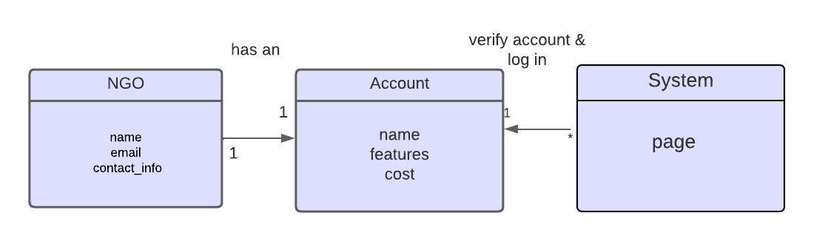

1. Modify Profile:

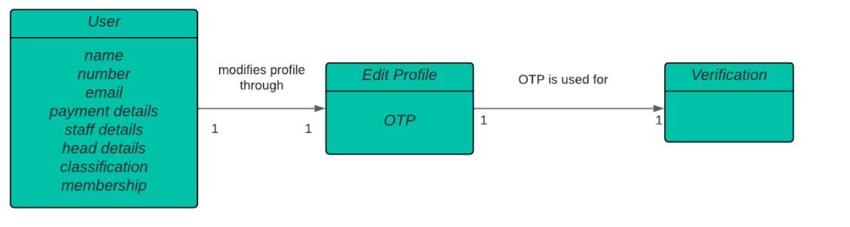

1. Donate To NGO:

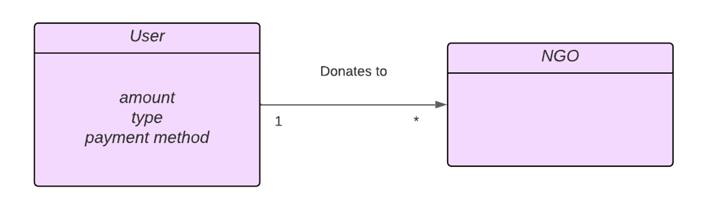

1. Process Payment:

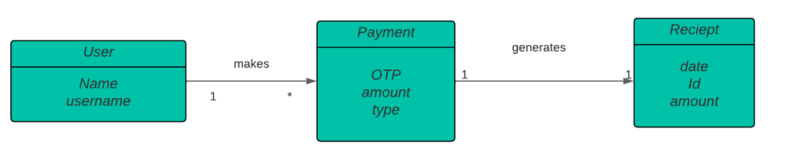

1. Book Visit To NGO:

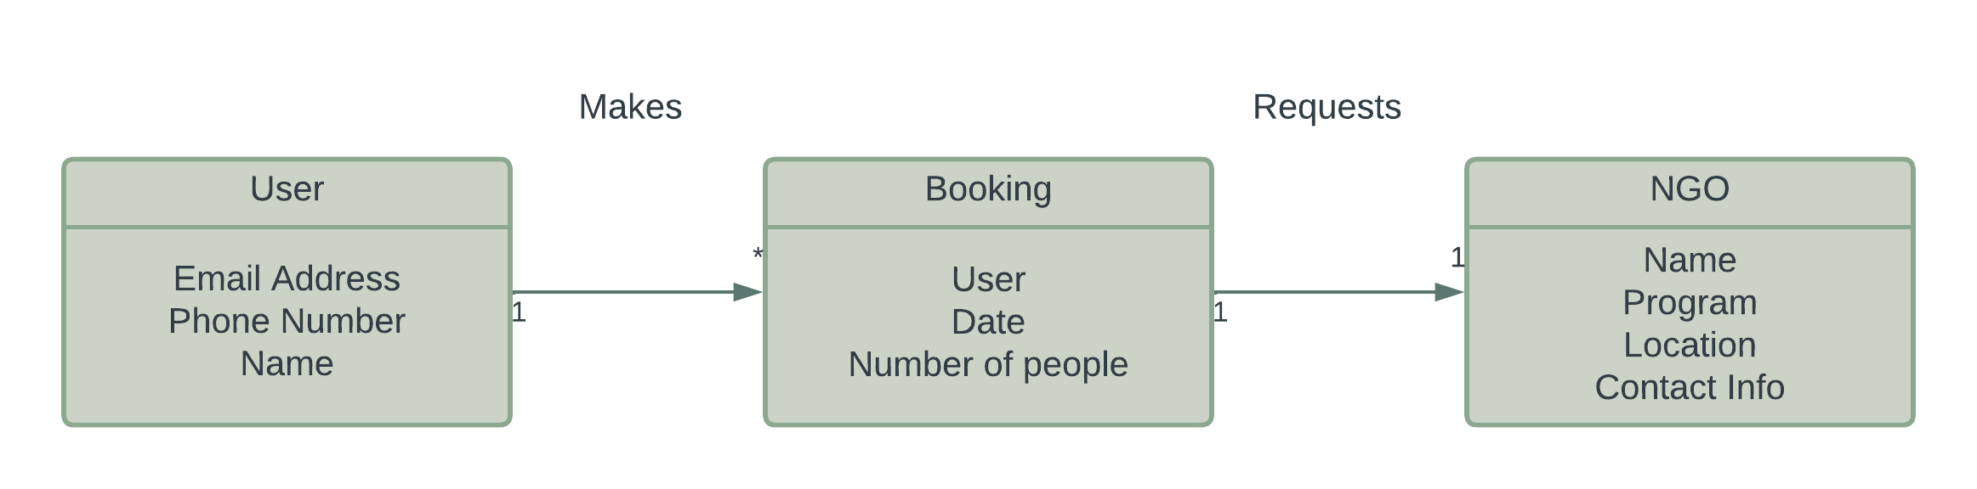



1. Get Help From NGO:

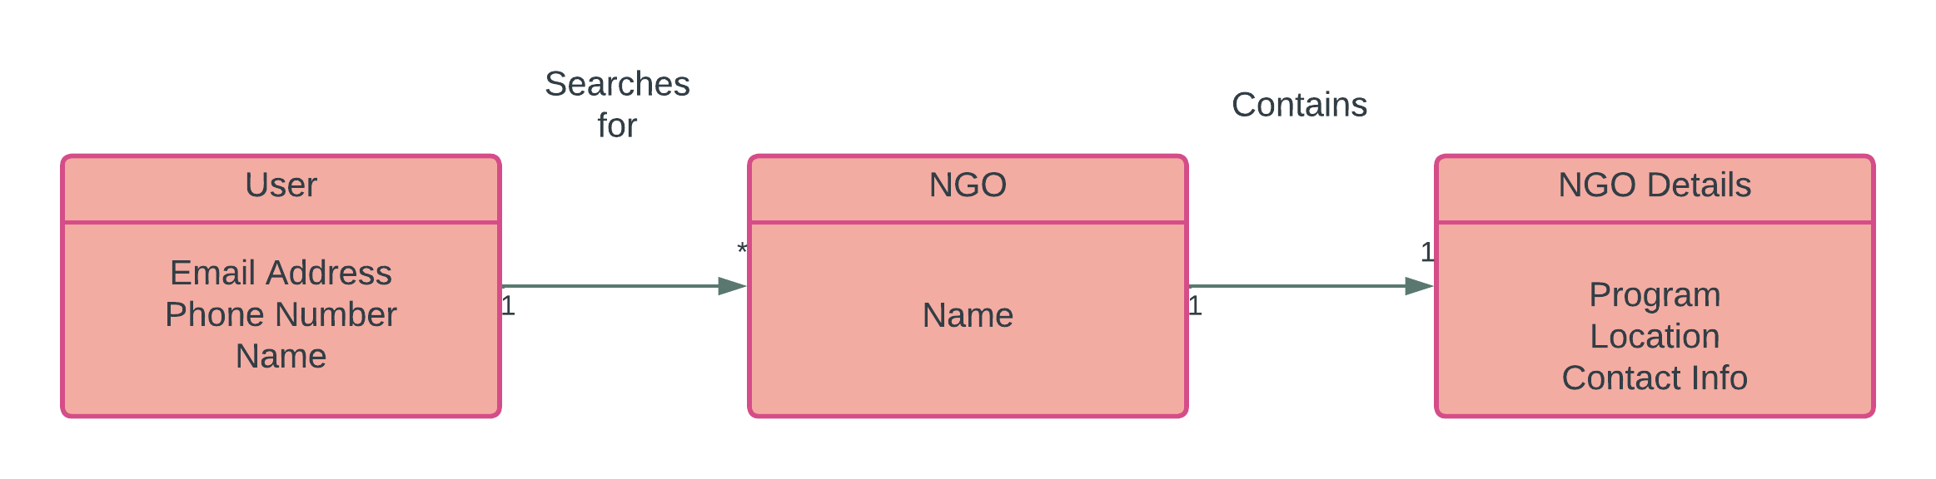



1. Generate Reports:

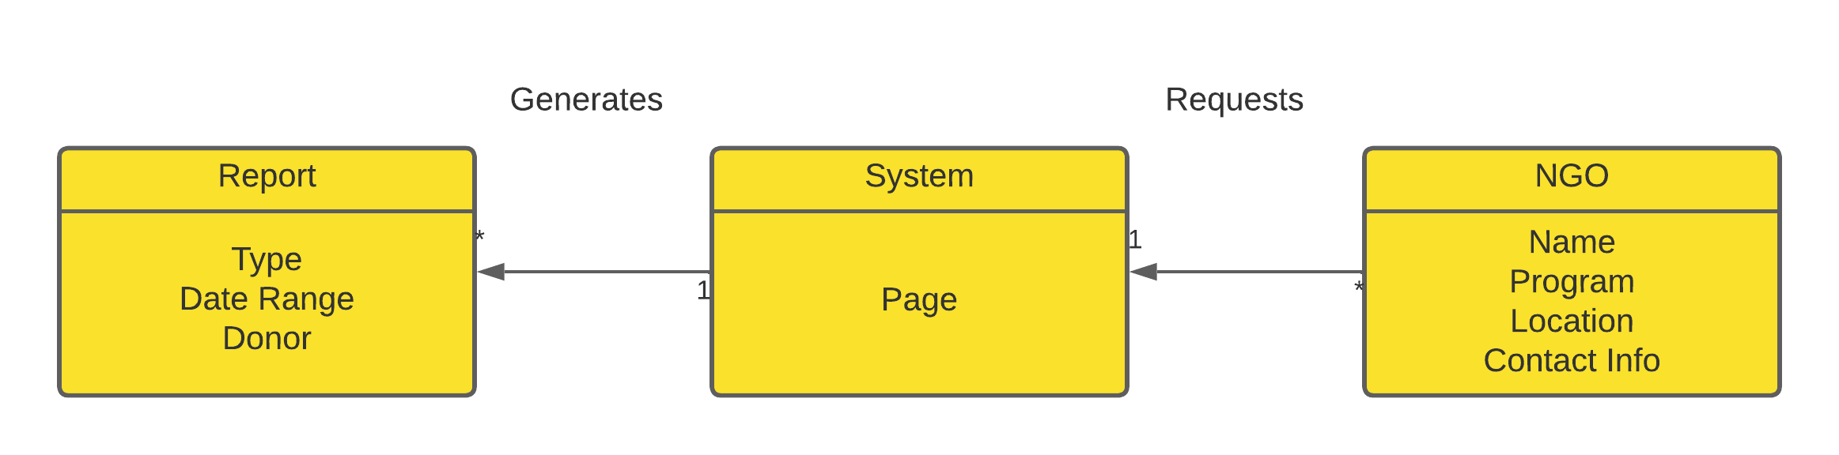



1. Logout

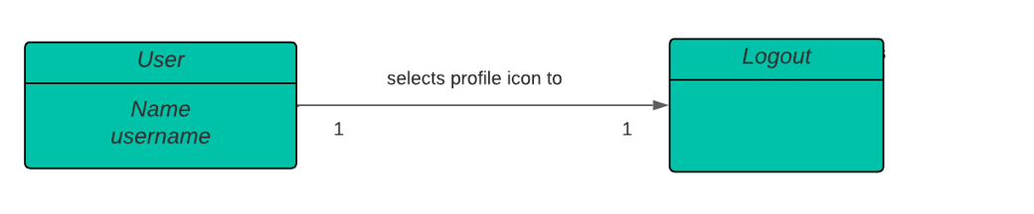

# Sequence Diagrams for Use Cases

1. 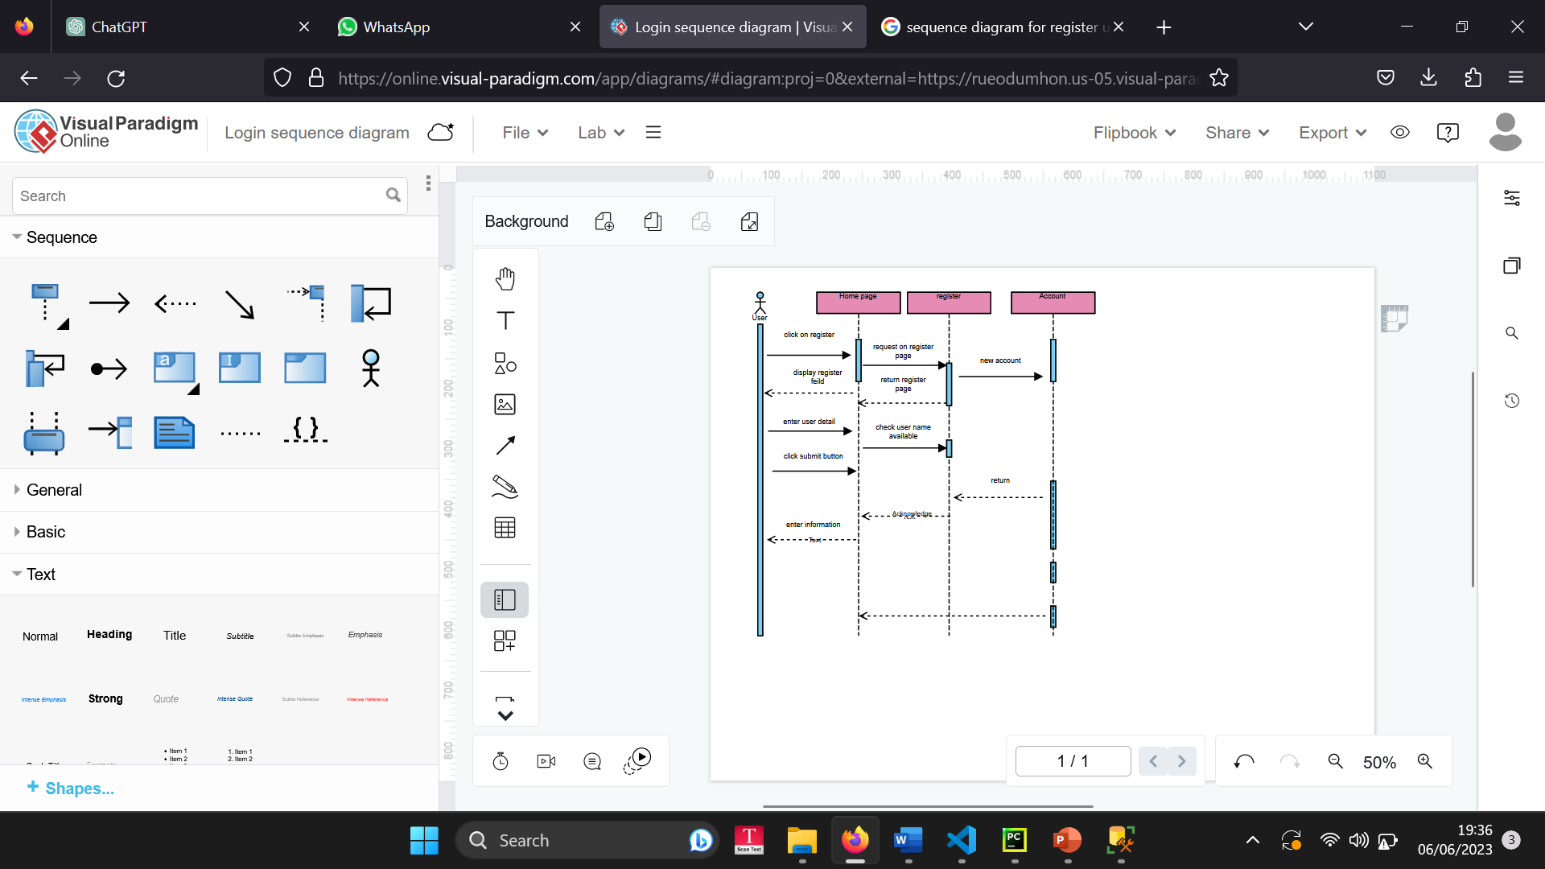Register User:
2. 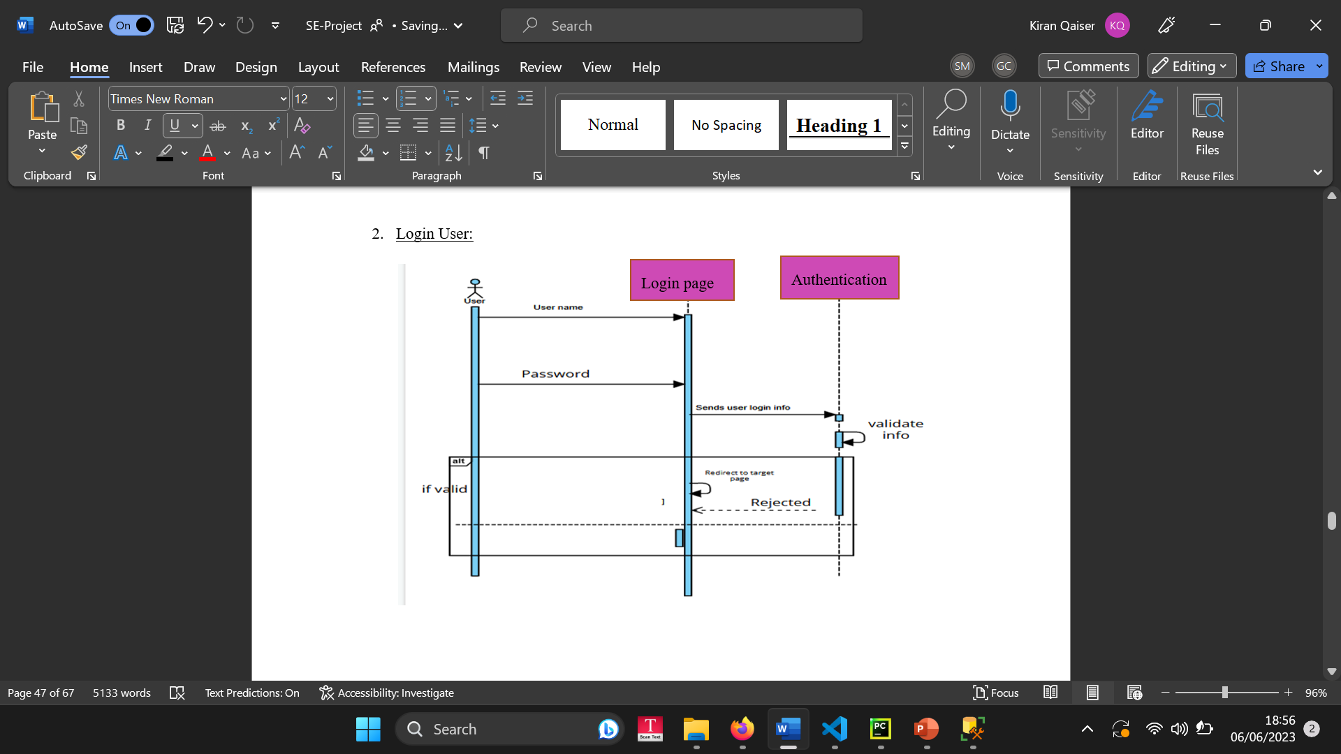Login User / Login NGO:
3. 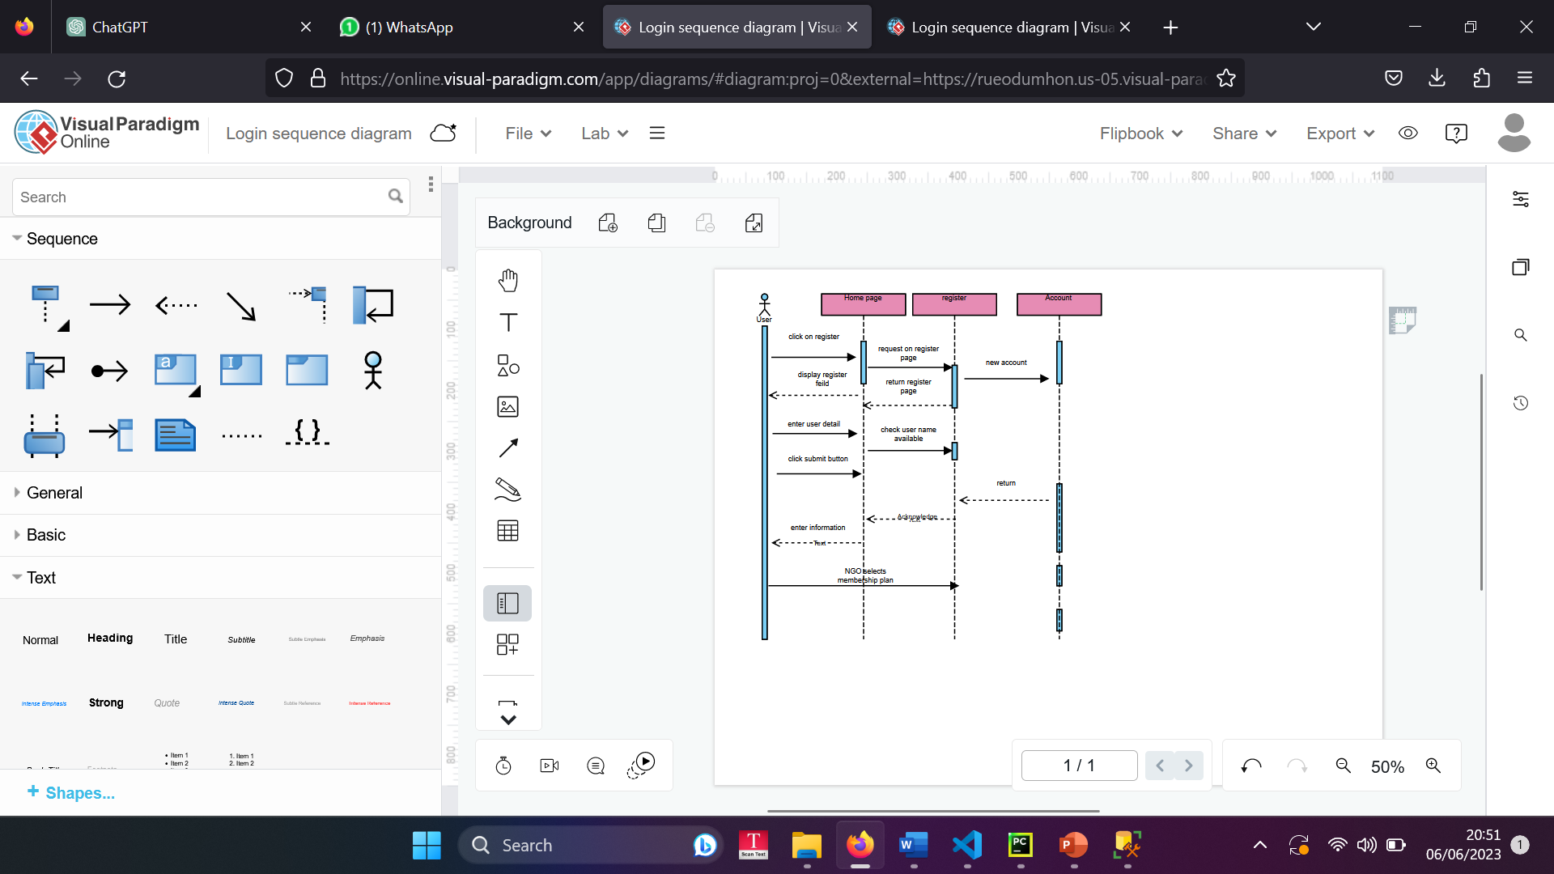Register NGO:
4. 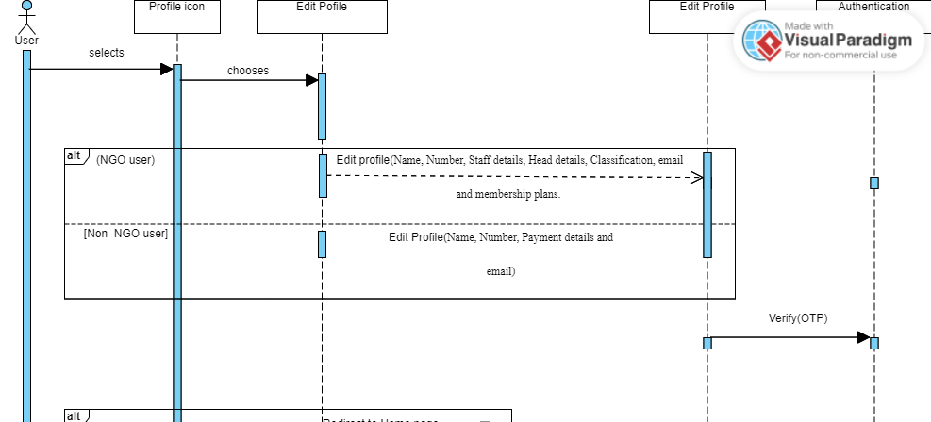Modify Profile:
5. Donate To NGO:

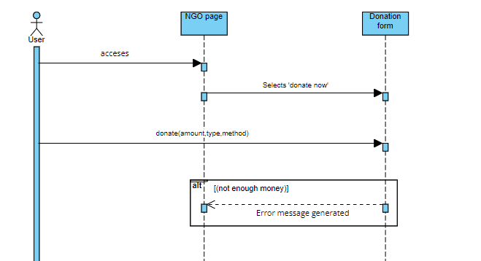

1. Process Payment:

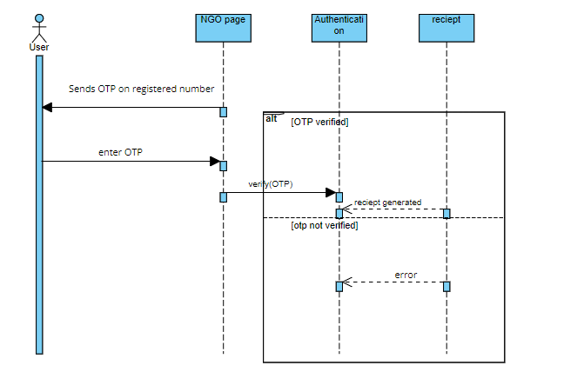

1. 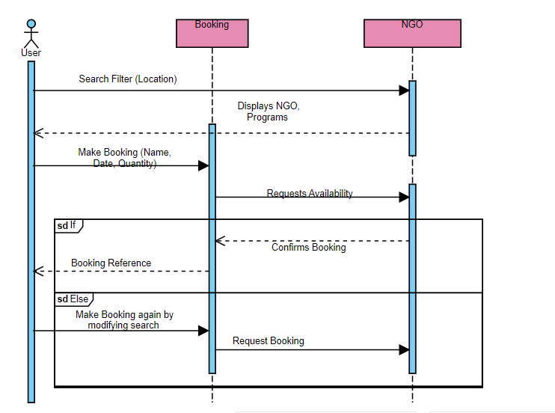Book Visit To NGO:
2. Get Help From NGO:

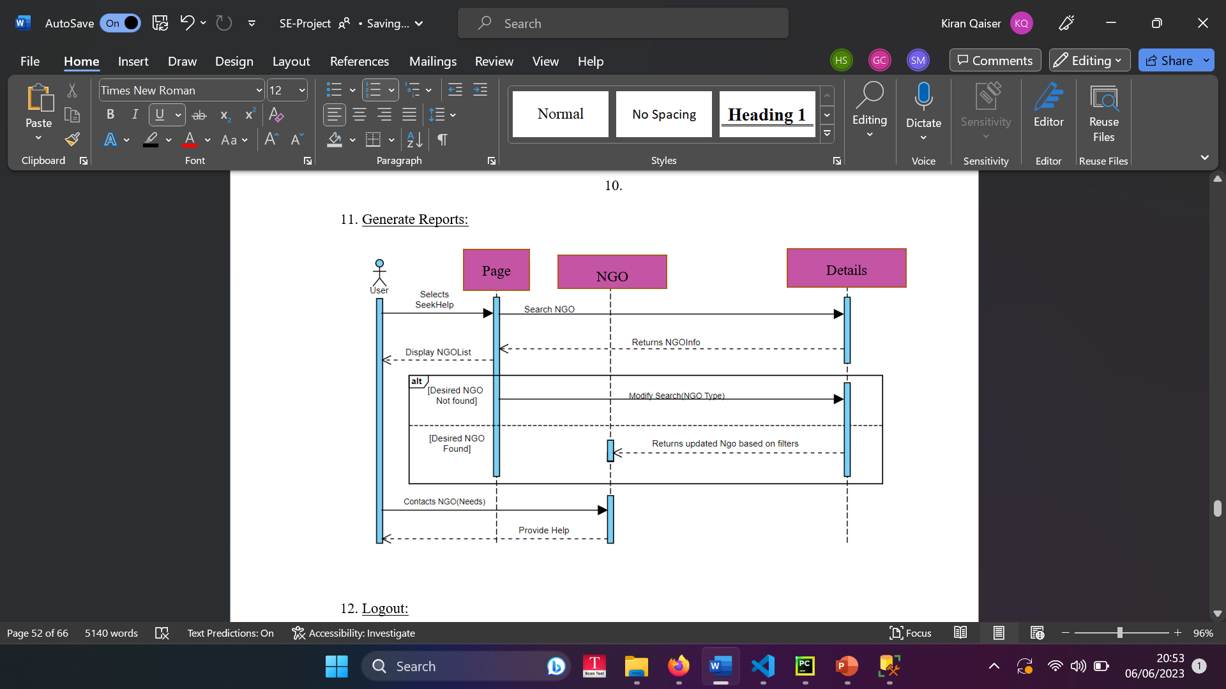

1. Generate Reports:

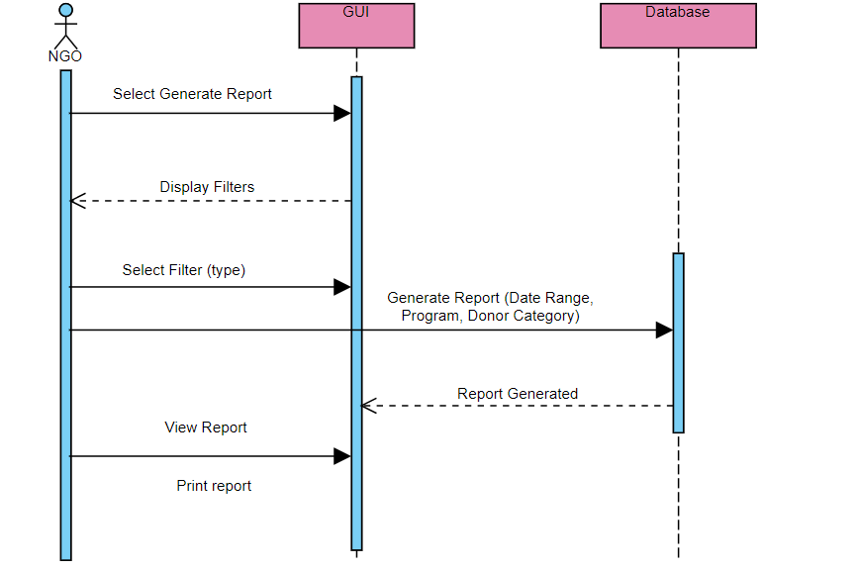

1. Logout:

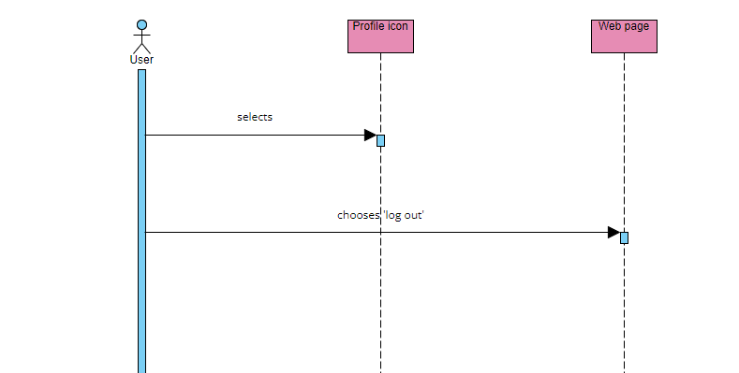

# Class Diagrams for Use Cases

1. Register User:

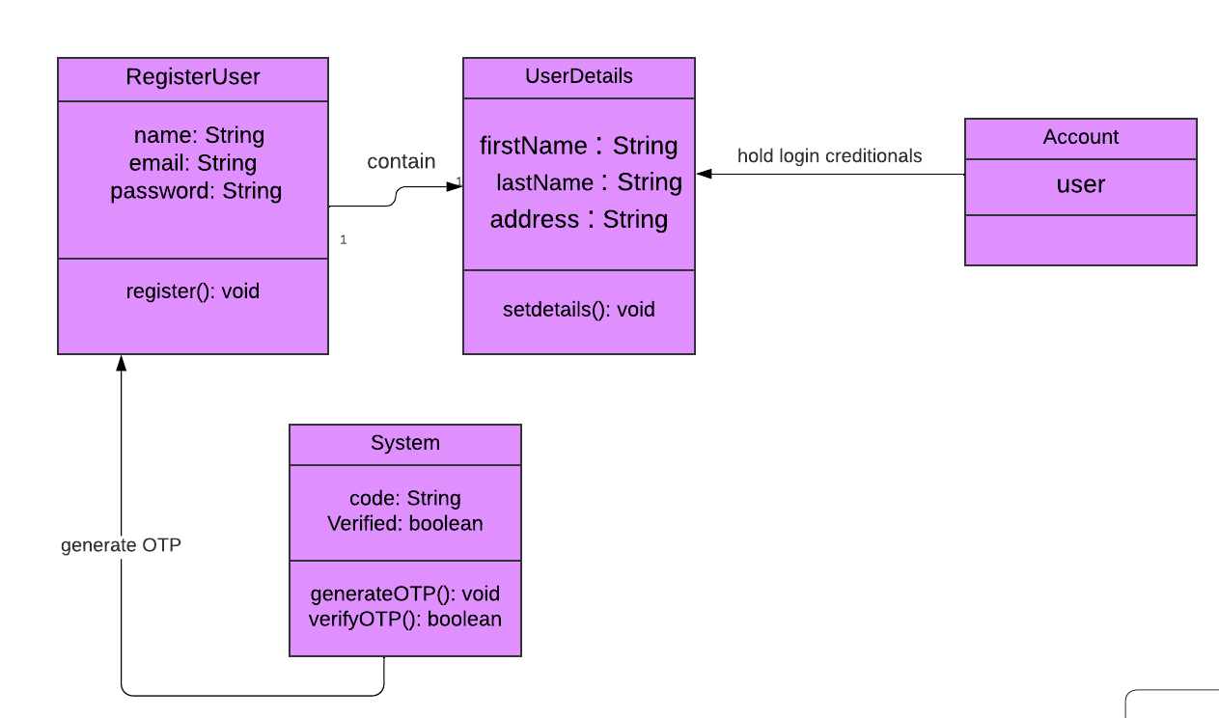

1. Login User:

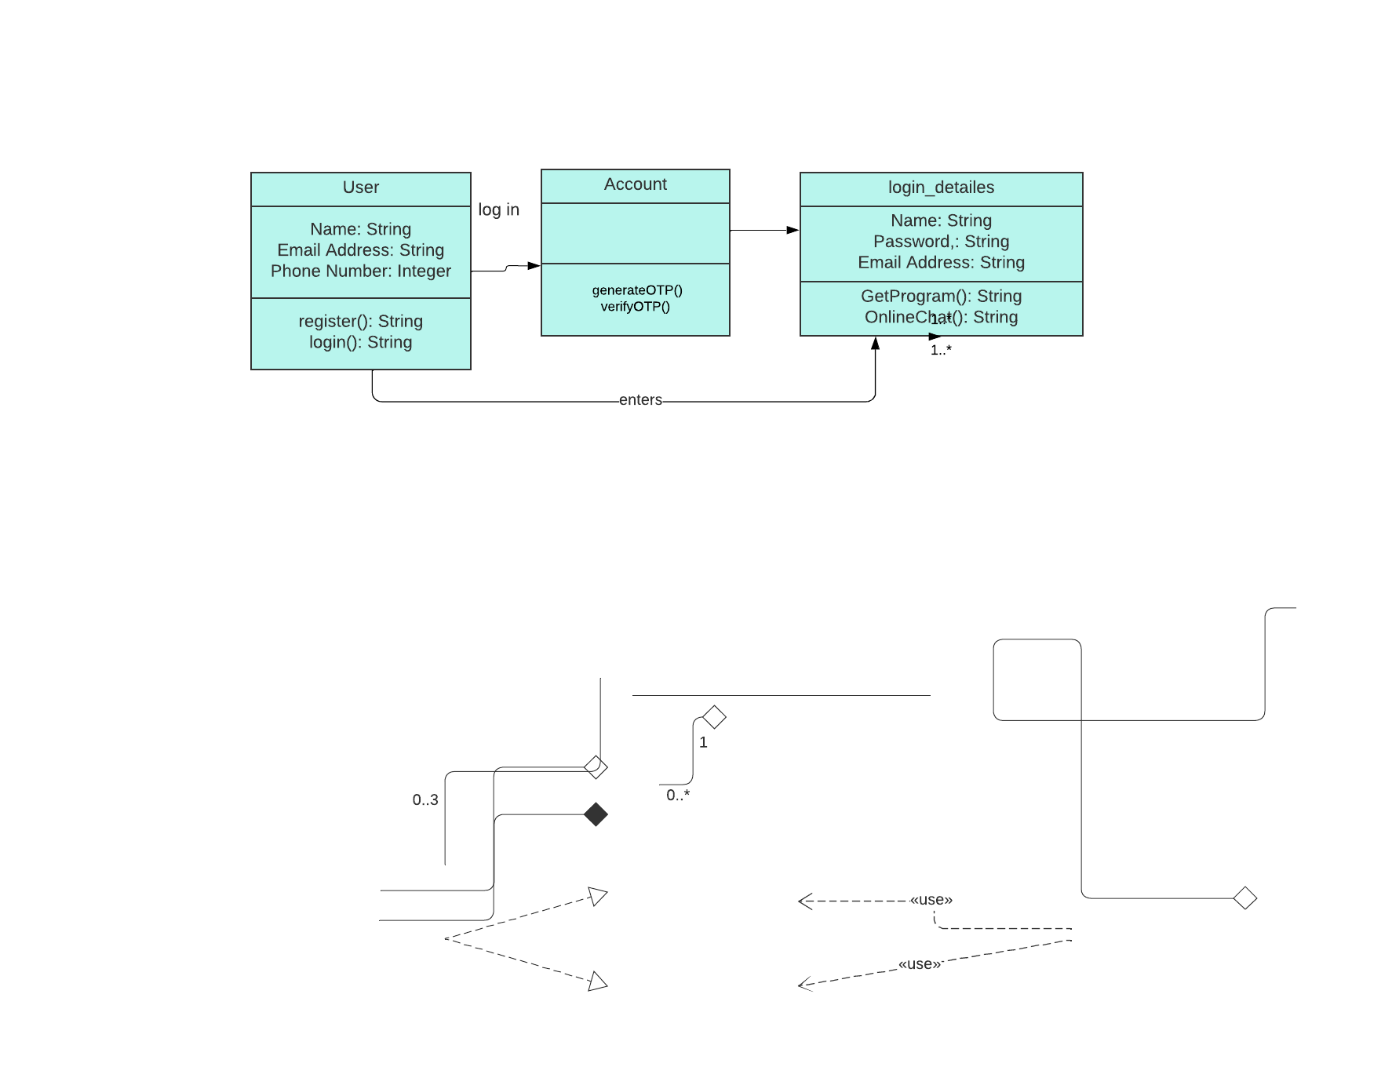

1. Register NGO:

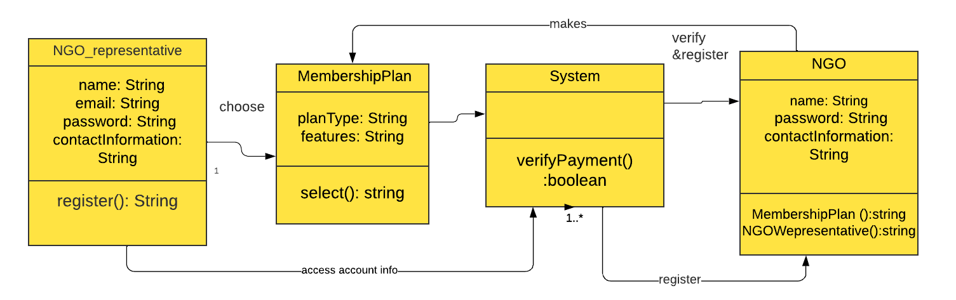

1. Login NGO:

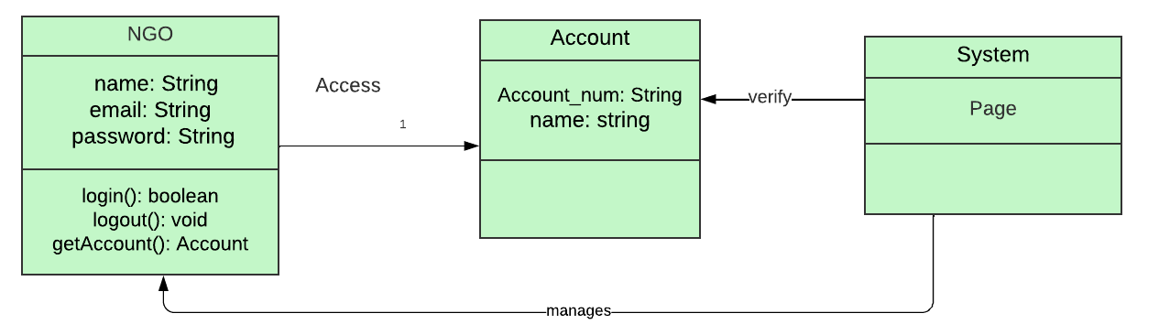

1. Modify Profile:

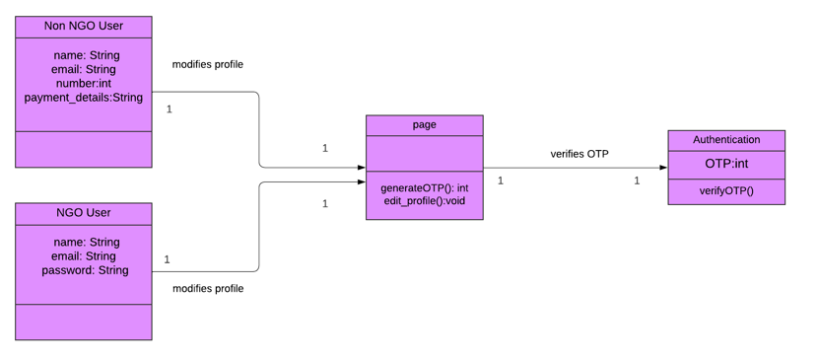

1. Donate To NGO:

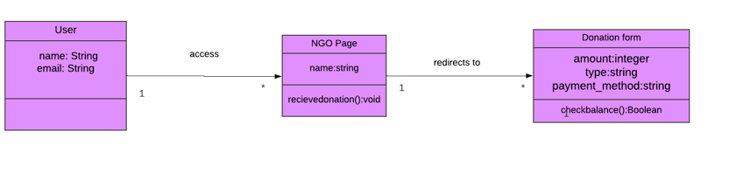

1. 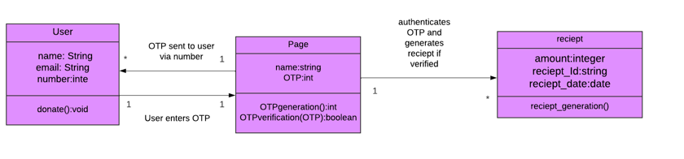Process Payment
2. Book Visit To NGO:

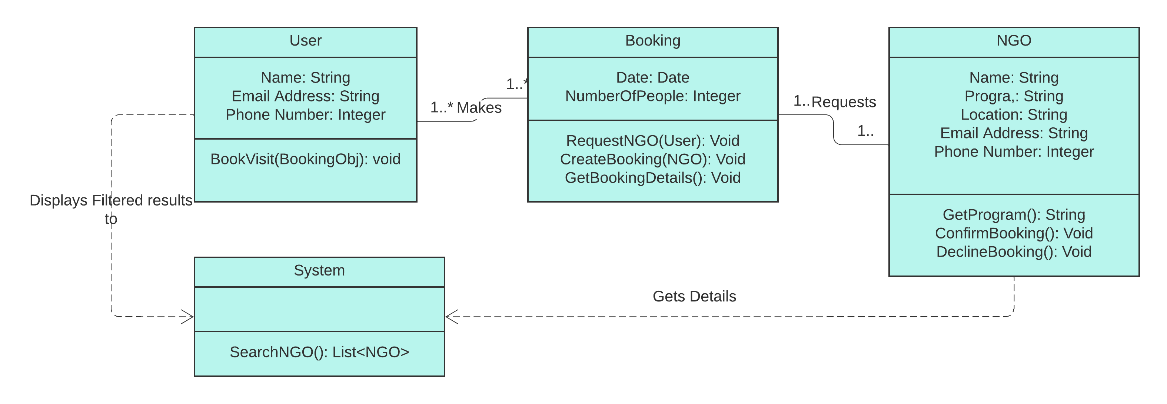

1. 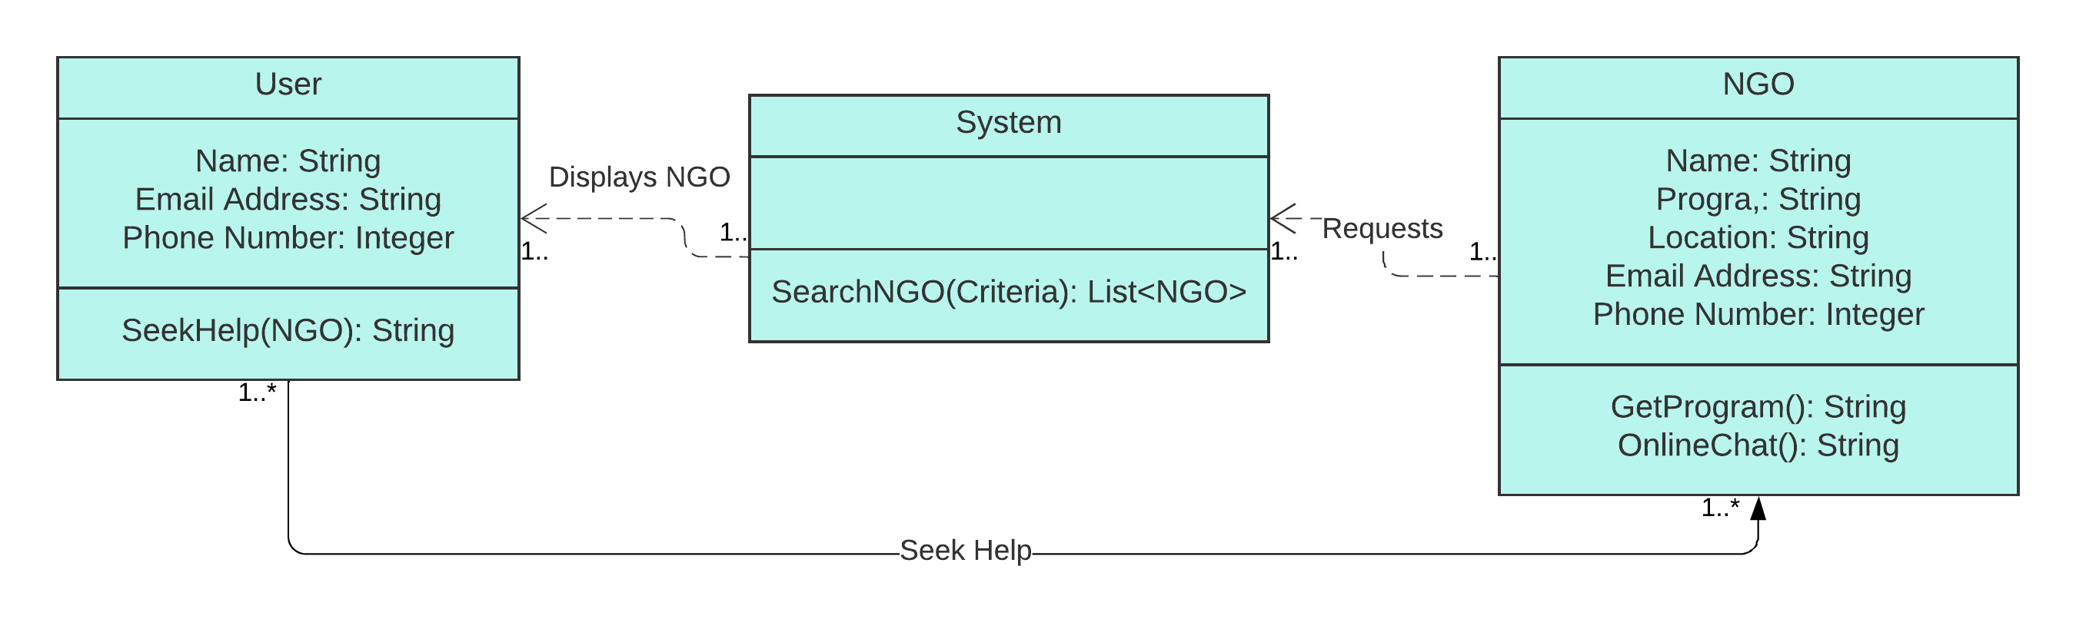Get Help From NGO:
2. 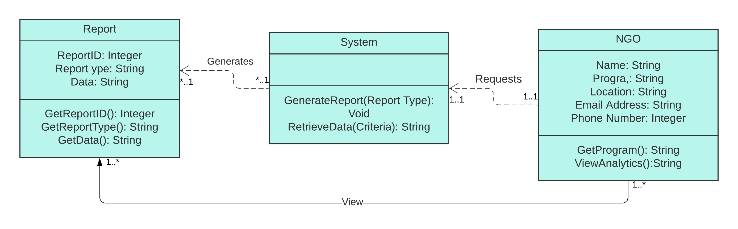Generate Reports:
3. Logout:

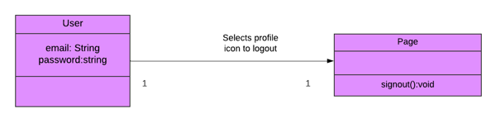

# User Interface

Website [link](https://selleramazonpks.wixsite.com/mysite)

* Home Page for the site, Where the User can Select the top right icon to signup/ login.

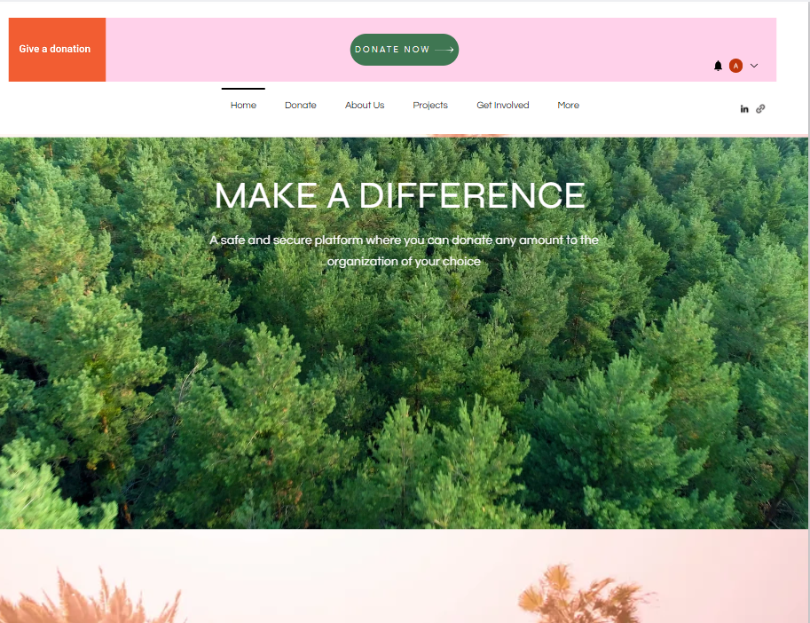

* 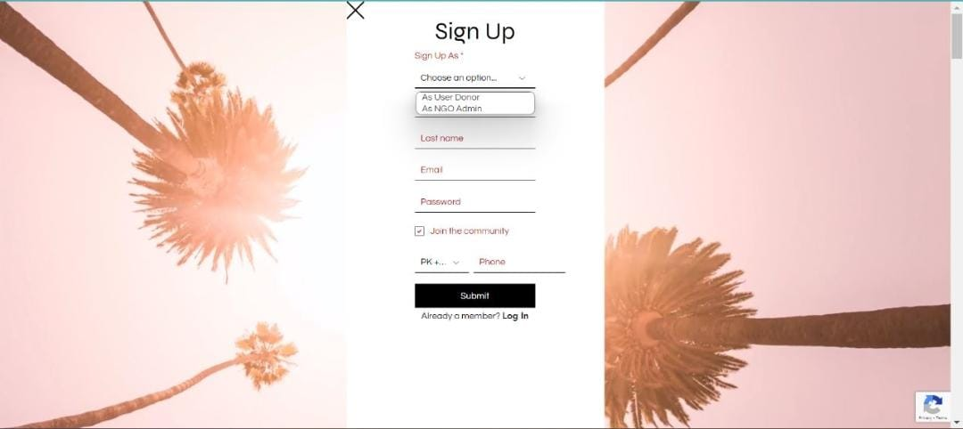User can select from the drop down menu whether to sign up as a user or as NGO
* Sign up page for User where the user’s email address gets verified with OTP and password length is set to a minimum of 8 characters.

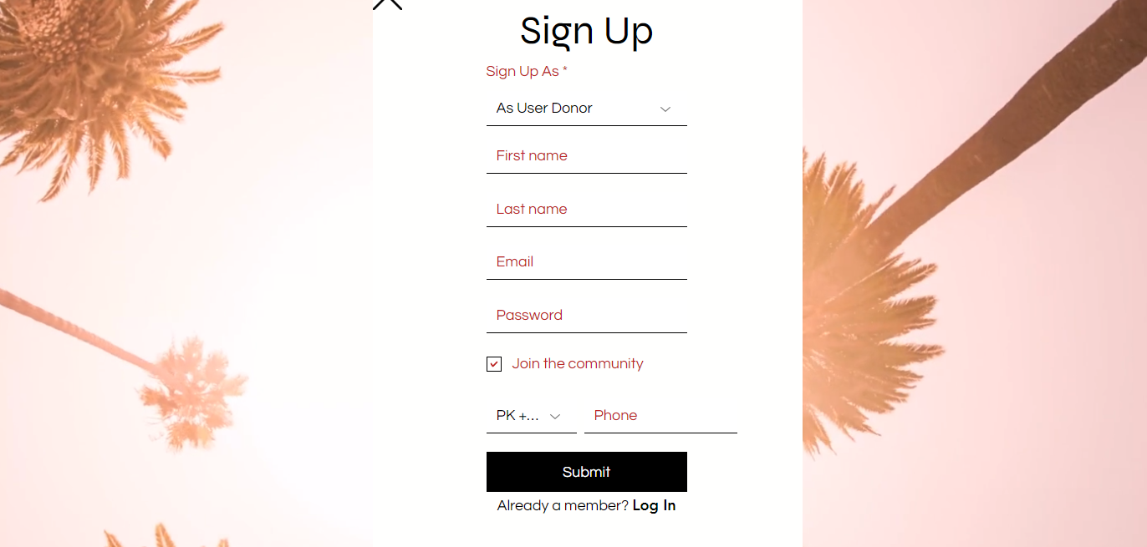

* Sign Up page for NGO where detailed information is asked about the NGO and the NGO gets notified through email to submit further documents once qualified for registration.

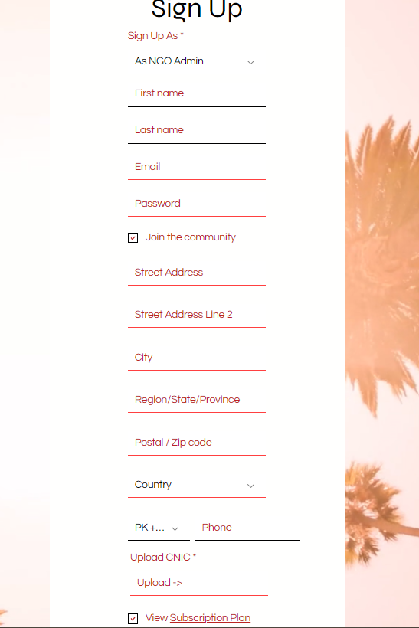

* Sign Up page for NGO where detailed information is asked about the NGO like complete address and CNIC to be uploaded. The NGO gets notified through email to submit further documents once qualified for registration. The NGO needs to select their membership plan whether paid or free.
* The paid plan offers more features which allows the NGO to stand out on the webpage with the marketing SEO provided thus reducing the costs for NGO advertising. With in depth analytic tools for tracking, recording and reporting.
* Donation Tracking
* Donation Reporting
* Donor Lifecycle Analytics
* Donor Records
* Automatic Email Receipts
* Unlimited Custom Reports
* Scheduled Reports
* Advertising and Marketing

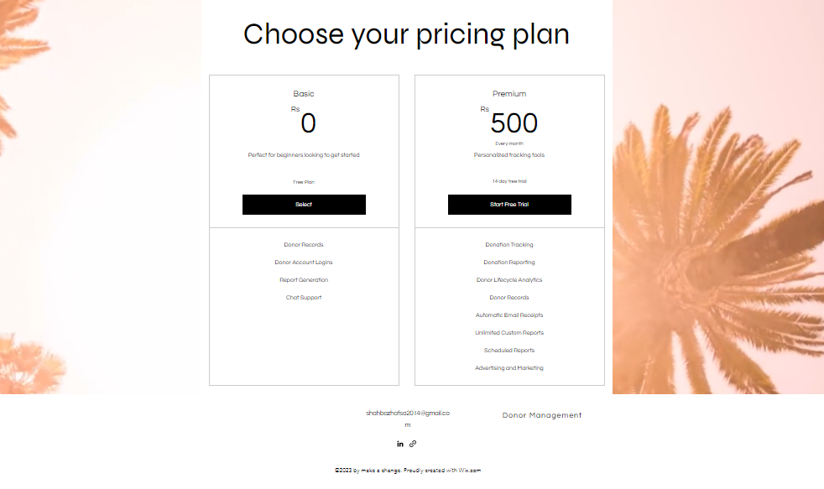

* Login page which includes login via email or google account making it easier for logging in.

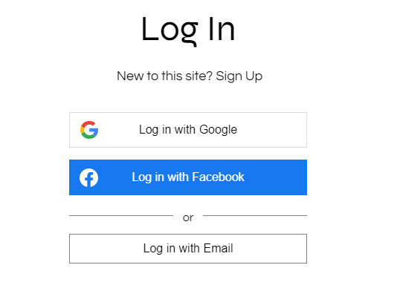

* 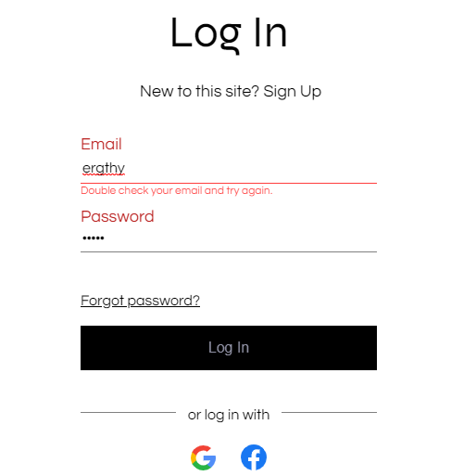Prompts the user to enter correct Login details and conducts OTP verification through email
* Users can modify their profile after login and update their contact information, wallet information for faster donation payments, save bank cards for later use, edit, add and remove them.
* They can view their donation receipts, and the bookings they might have made to visit the NGOs

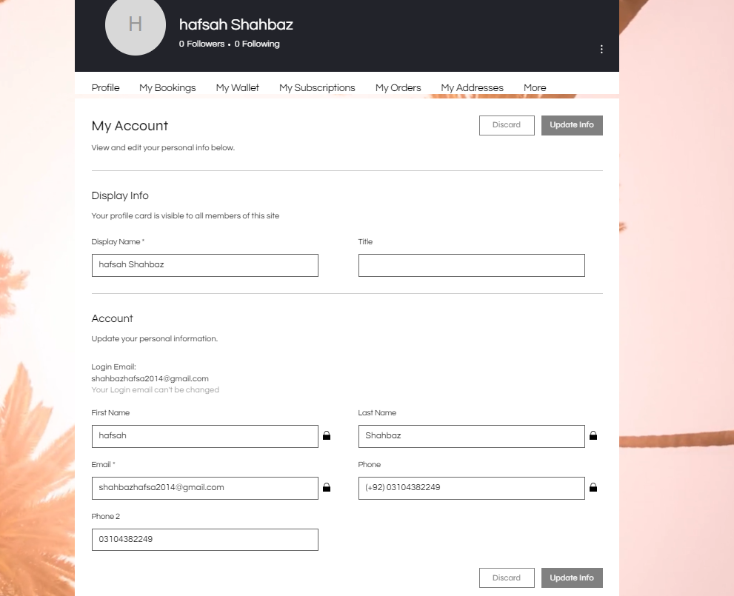

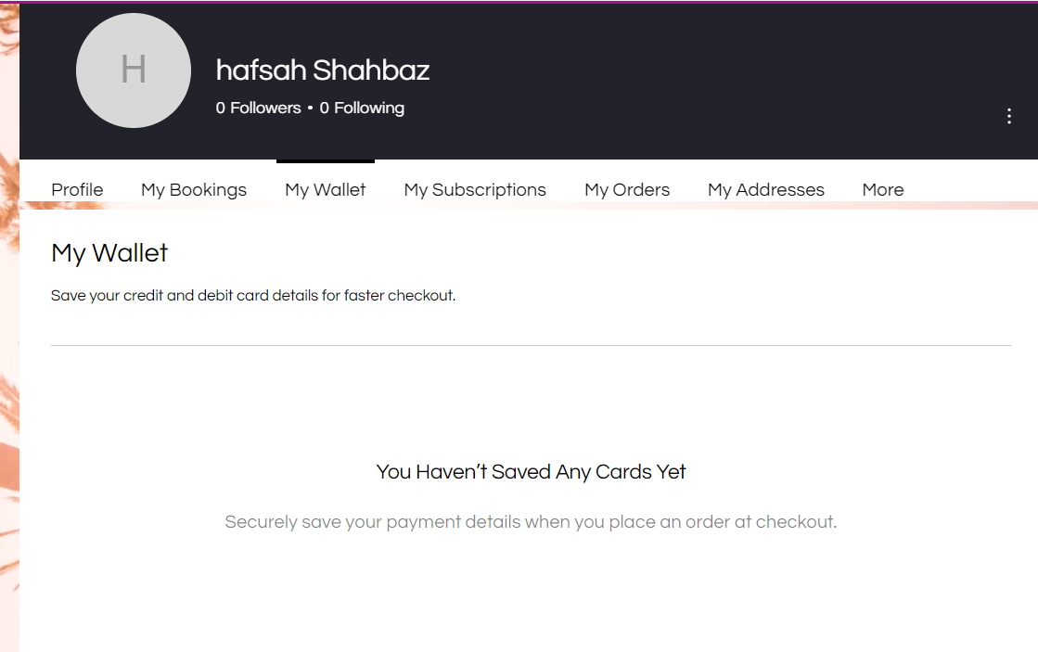

* Select from the various NGOs of your choice based on category of service they provide and filters like near me. Search Results shows the list of NGOs based on their category of service. The type of donation to provide either zakat, charity, etc, Streamlining the donation experience.

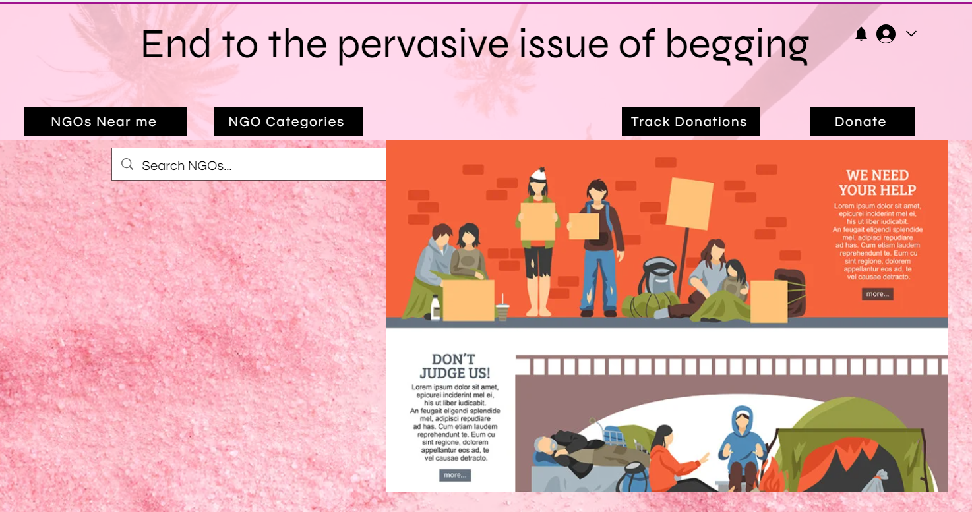

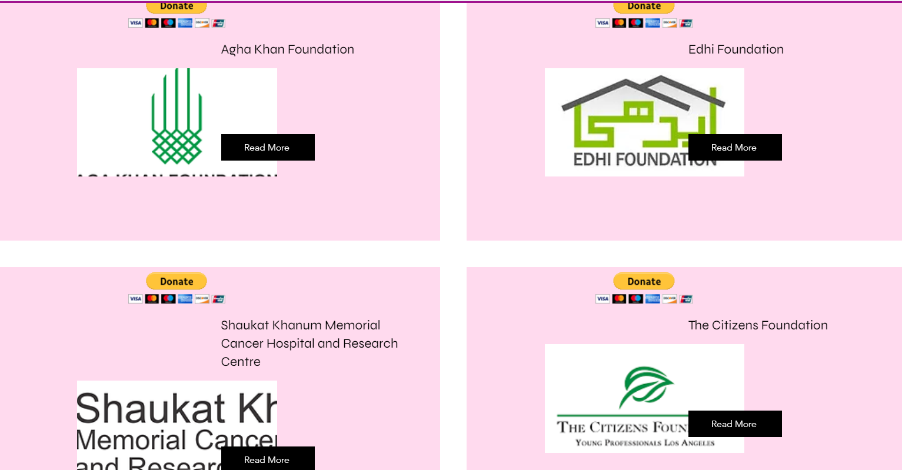

* Near me filters can be applied which shows all the nearby NGOs and the user can simply select it and donate directly or visit them by booking online.

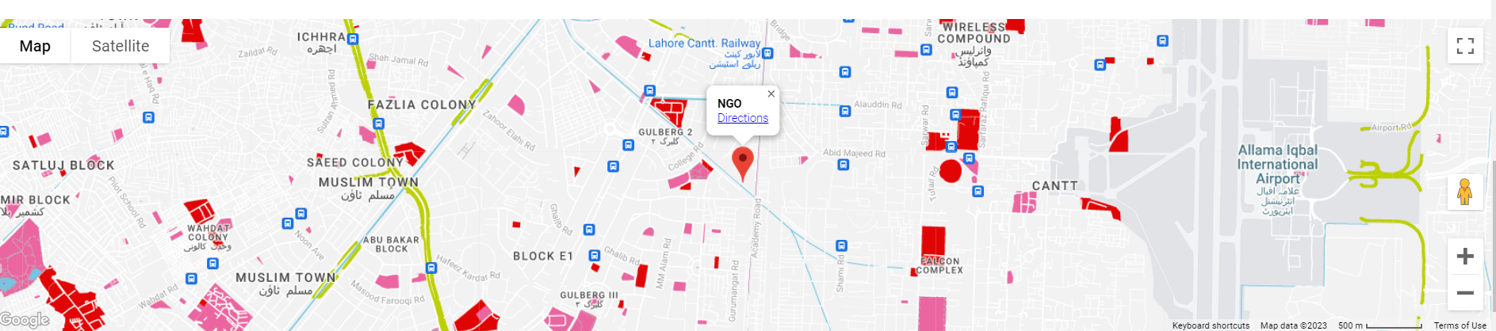

* Multiple Payment options to select from when making a donation

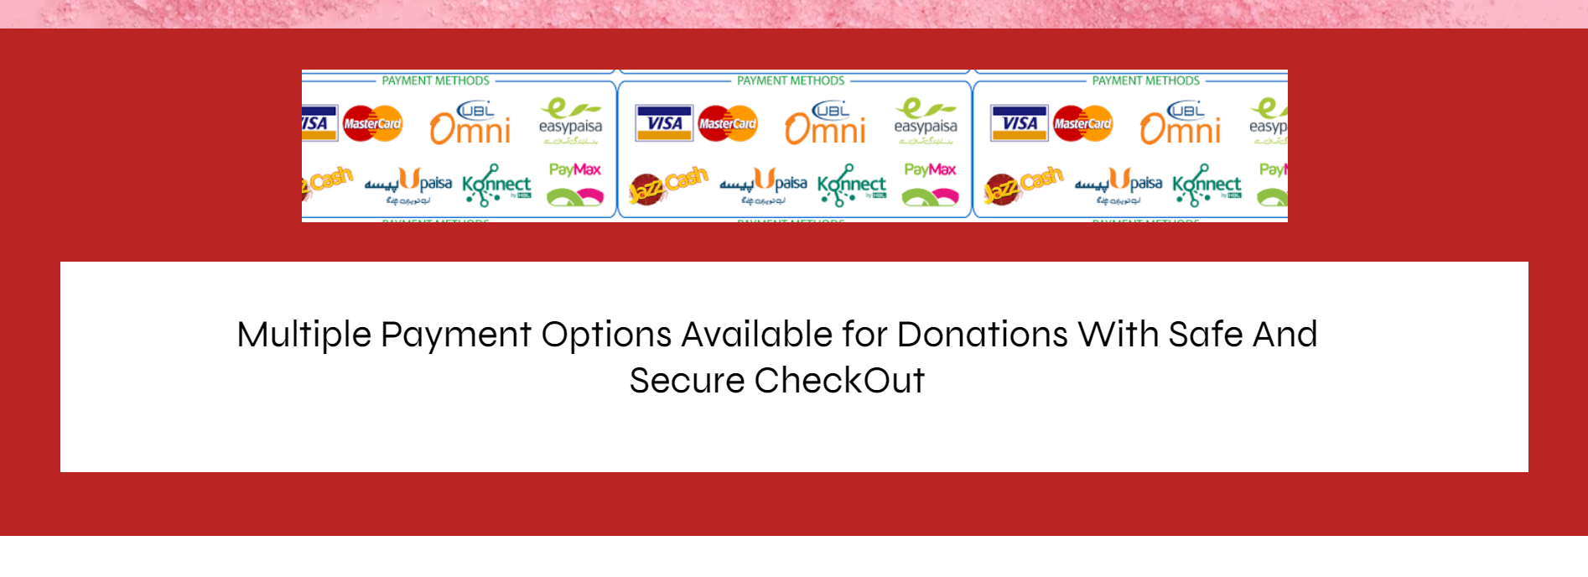

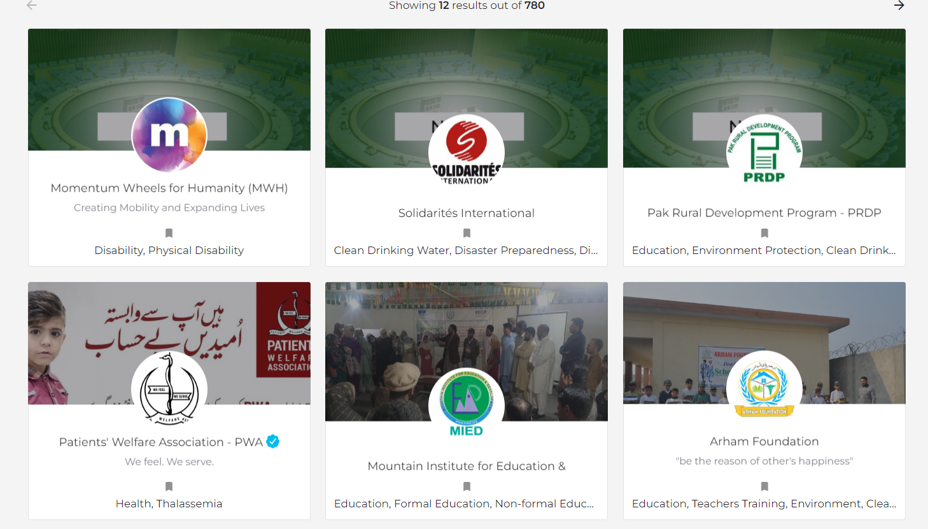

* Users can seek help from NGOs: It allows users to explore various types of assistance provided by NGOs and establish communication for their specific needs.

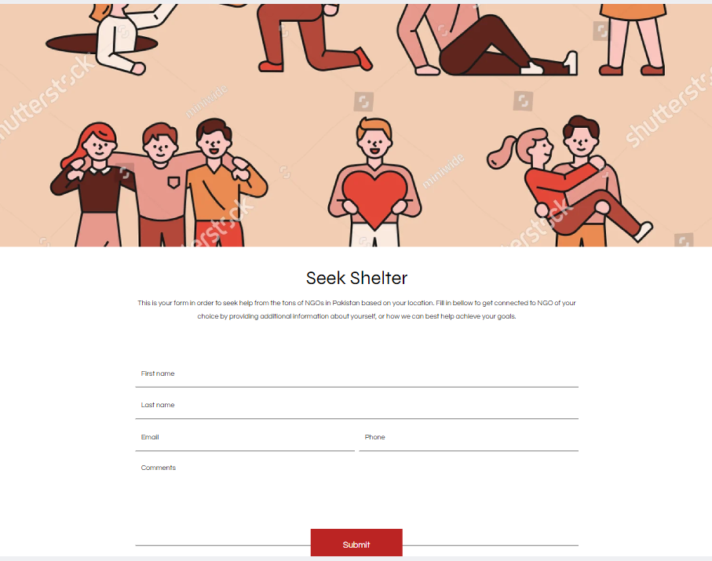

* Users can book visits to NGOs and the NGOs can confirm their bookings and accommodate the number of visitors.
* Easy interactive calendars for faster interaction with the NGO and efficient communication and assistance provided

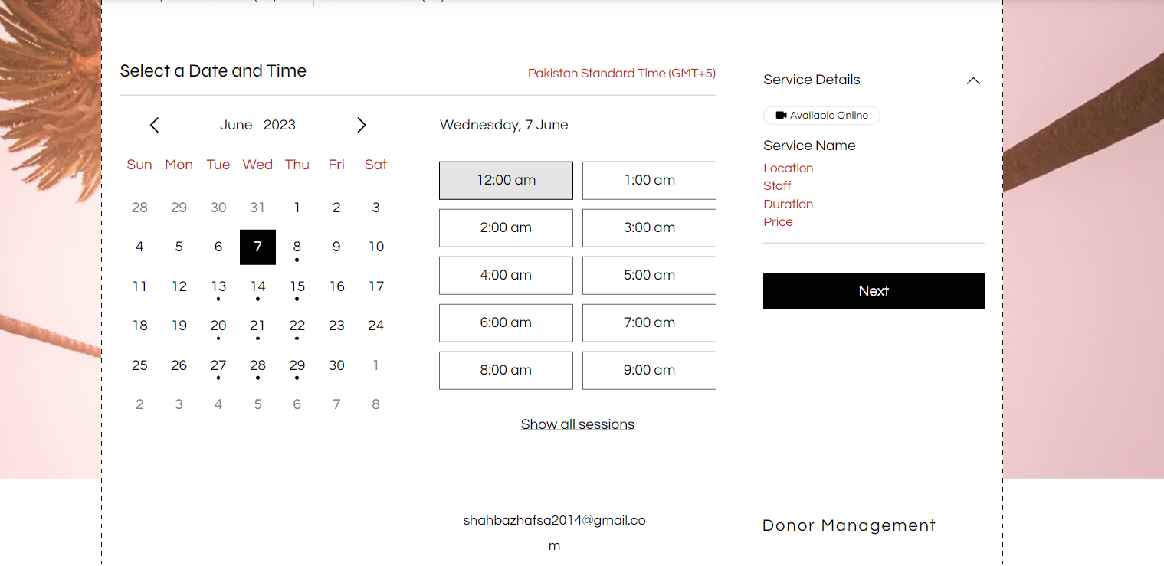

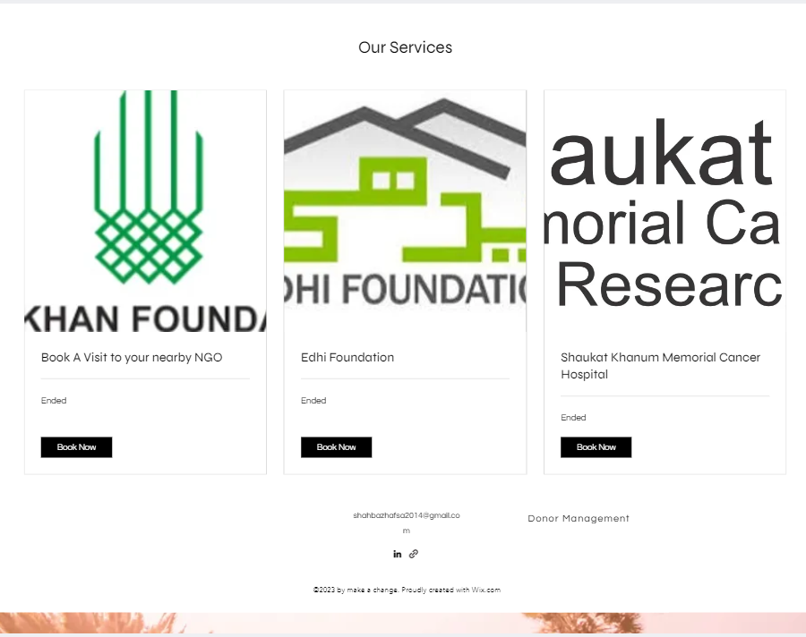

* NGOs have access to a ton of tools that they can use to become effective

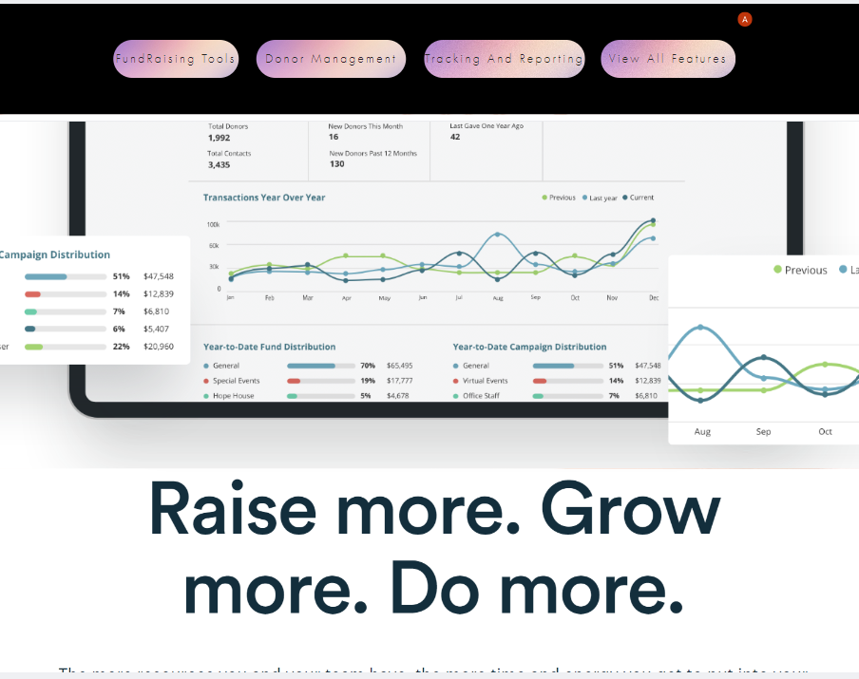

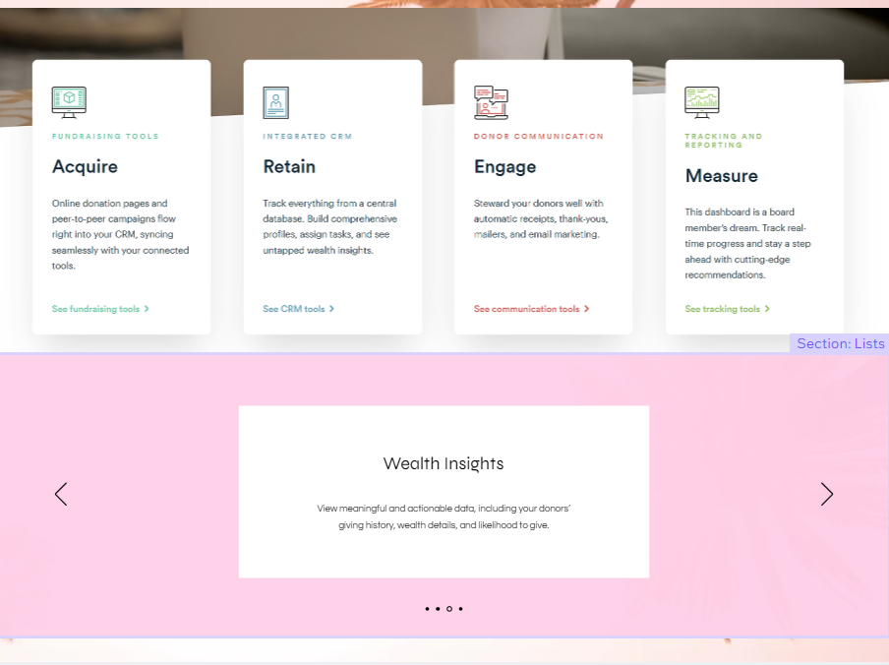

# Test Cases

**TEST CASE 1:**

|  |
| --- |
| **Test Case ID:** 100 a **Test Case Name:** Register User **Test Case Priority:**  High **Test Case Pre-requisite:** The donor registration system is available and prepared. **Test Case Post-requisite:** The system has successfully recorded the donor's data. |

|  |  |  |  |  |  |  |
| --- | --- | --- | --- | --- | --- | --- |
| **SrNo** | **Action** | **Input** | **Expected Output** | **Actual Output** | **Result** | **Comment** |
| **1** | User accesses the registration page and enters Email/Phone Number and password. | Rafay 022920239302 Gullberg 3, Lahore Pakistan. | Registration page is displayed. | Registration page is displayed. | User is registered. | The system should send an OTP for verification to the user's email address or phone number. |

**TEST CASE 2:**

|  |
| --- |
| **Test Case ID:** 101b **Test Case Name:** Login User **Test Case Priority:**  High **Test Case Pre-requisite:** The user has active login credentials and has registered on the app.  **Test Case Post-requisite:** After successfully logging in, the user is given access to their account. |

|  |  |  |  |  |  |  |
| --- | --- | --- | --- | --- | --- | --- |
| **SrNo** | **Action** | **Input** | **Expected Output** | **Actual Output** | **Result** | **Comment** |
| **2** | To login user enters Email /phone number and password. | Email/Phone abc@gmail.com/0300234123 Password: abcd123 | The system sends an OTP (One-Time Password) | The system sends an OTP (One-Time Password) | Takes user to his account. | The system should validate the OTP and grant access to the user's account. |

**TEST CASE 3:**

|  |
| --- |
| **Test Case ID:** 103c **Test Case Name:** Register NGO **Test Case Priority:**  High **Test Case Pre-requisite:** The NGO representative seeks to register their organization and has access to the donation management system.  **Test Case Post-requisite:** The NGO is identified and acknowledged in the contribution management system upon successful registration with the selected membership plan applied. |

|  |  |  |  |  |  |  |
| --- | --- | --- | --- | --- | --- | --- |
| **SrNo** | **Action** | **Input** | **Expected Output** | **Actual Output** | **Result** | **Comment** |
| **3** | NGO representative selects NGO registration and enter the details. | Email/Phone abc@gmail.com/0300234123 Password: abcd123 | NGO registration form is displayed. | NGO registration form is displayed. | Account is registered. | The NGO representative should be able to enter the required details and upload supporting documents. |

**TEST CASE 4:**

|  |
| --- |
| **Test Case ID:** 103c **Test Case Name:** Login NGO **Test Case Priority:**  High **Test Case Pre-requisite:** The NGO must be already registered on the website.**Test Case Post-requisite:** The NGO logs in and gains access to its account. |

|  |  |  |  |  |  |  |
| --- | --- | --- | --- | --- | --- | --- |
| **SrNo** | **Action** | **Input** | **Expected Output** | **Actual Output** | **Result** | **Comment** |
| **4** | NGO enters email/Phone Number and password | Email/Phone abc@gmail.com/0300234123 Password: abcd123 | The system sends an OTP (One-Time Password) | NGO registration form is displayed. | NGO login to the account. | The system should validate the OTP and grant access to the NGO's account. |

**TEST CASE 5:**

|  |
| --- |
| **Test Case ID:** 103c **Test Case Name:** Modify Profile **Test Case Priority:**  Medium **Test Case Pre-requisite:** User must be logged in.  **Post-requisite:** User edits its profile information. |

|  |  |  |  |  |  |  |
| --- | --- | --- | --- | --- | --- | --- |
| **SrNo** | **Action** | **Input** | **Expected** **Output** | **Actual** **Output** | **Result** | **Comment** |
| **5** | User accesses profile and edits information. | New Email: abc@gmail.com | The system sends an OTP (One-Time Password) ,verifies it and updates new information. | Email is changed to new email. | User profile modified. | The system should validate the OTP and update it. |

**TEST CASE 6:**

|  |
| --- |
| **Test Case ID:** 106c **Test Case Name:** Donate to NGO **Test Case Priority:**  High **Test Case Pre-requisite:** User must have added valid payment details.  **Post-requisite:** User submits donation form. |

|  |  |  |  |  |  |  |
| --- | --- | --- | --- | --- | --- | --- |
| **SrNo** | **Action** | **Input** | **Expected** **Output** | **Actual** **Output** | **Result** | **Comment** |
| **6a**  **6b** | User accesses an NGO page and selects ’donate now’.  User fills the donation forrm. | Amount: 3000  Type of donation: Sadqa  Method: bank account | Donation form opened.  Message saying form submitted | Donation form opened.  Back to NGO page | Donation form opened.  .  Back to page |  |

**TEST CASE 7:**

|  |  |  |  |  |  |  |
| --- | --- | --- | --- | --- | --- | --- |
| **Test Case ID:** 107c **Test Case Name:** Payment Processing **Test Case Priority:**  High **Test Case Pre-requisite:** The user must provide valid payment information.  **Post-requisite:** Confirmation of transaction. | | | | | | |
| **SrNo** | **Action** | **Input** | **Expected** **Output** | **Actual** **Output** | **Result** | **Comment** |
| **7** | The user enters an OTP. | 43571 | Receipt is generated. | Receipt is generated. | OTP is verified and a reciept in generated. | The system should sends an OTP to the user for verification. |

**TEST CASE 8:**

|  |
| --- |
| **Test Case ID:** 103c **Test Case Name:** Book Visit to NGO **Test Case Priority:**  Medium **Test Case Pre-requisite:** The user has registered and logged into the system. The user has access to the list of NGOs and their available programs.  **Post-requisite:** The user successfully books a visit to the chosen NGO program and receives confirmation with the necessary details. |

|  |  |  |  |  |  |  |
| --- | --- | --- | --- | --- | --- | --- |
| **SrNo** | **Action** | **Input** | **Expected Output** | **Actual Output** | **Result** | **Comment** |
| **8** | The user selects the option to browse NGOs and their programs. | User login | The system displays a list of NGOs and their available programs. | The system displays a list of NGOs and their available programs. | NGO login to the account. | The system should filter the list of NGOs based on the user's selected filters. |

**TEST CASE 9:**

|  |
| --- |
| **Test Case ID:** 109I **Test Case Name:** Get Help From NGO **Test Case Priority:** High **Test Case Pre-requisite:** The user has registered and logged into the system.  **Post-requisite:** The user receives the requested help or support from the selected NGO. The user and the NGO maintain communication for ongoing assistance, if required. |

|  |  |  |  |  |  |  |
| --- | --- | --- | --- | --- | --- | --- |
| **SrNo** | **Action** | **Input** | **Expected Output** | **Actual Output** | **Result** | **Comment** |
| **9** | The user selects the option to seek help from the available menu. | User login | The system presents a list of NGOs that offer various types of assistance. | The system presents a list of NGOs that offer various types of assistance. |  | The user should be able to access the menu to seek help from NGOs. |

**TEST CASE 10:**

|  |  |  |  |  |  |  |
| --- | --- | --- | --- | --- | --- | --- |
| **Test Case ID:** 110 **Test Case Name:** Logout **Test Case Priority:** High **Test Case Pre-requisite:** The user must be logged in.  **Post-requisite:** The user is logged out. | | | | | | |
| **SrNo** | **Action** | **Input** | **Expected** **Output** | **Actual** **Output** | **Result** | **Comment** |
| **10** | The user selects profile icon.It then selects ‘logout’. |  | User is logged out. | The system redirects to home page. | User is logged out. |  |

# Future Work

1. Social Media Integration
2. Automated Tax Receipts
3. Donor Profiles and History
4. Volunteer Management
5. Matching Donations: Donations to be matched by corporate sponsors or individuals.
6. Impact Tracking
7. Collaboration with Corporate Partners
8. Website Development
9. Gamification and Incentive
10. International Expansion

# Conclusion

The donation management mobile app is a much-needed solution that will provide a secure and transparent platform for donors and NGOs to manage donations. In conclusion, the Donation Management Software project is a powerful and transformative solution that aims to revolutionize the donation process and put an end to the pervasive issue of begging. Establishing a collective forum of regulated donation of money and goods can be an effective way to support a project or a cause by establishing a centralized platform, contributors may be helpful with ease and have faith that their contributions will be used wisely and openly.

Beyond just Raising funds, it can foster a sense of responsibility and openness while raising knowledge and support for the cause. Users can contribute to their preferred cause or project. It may find the donation procedure to be more approachable and convenient as a result.

With robust security measures and a user-friendly interface, the app has the potential to revolutionize the donation process and make a significant impact on the lives of people in need.

